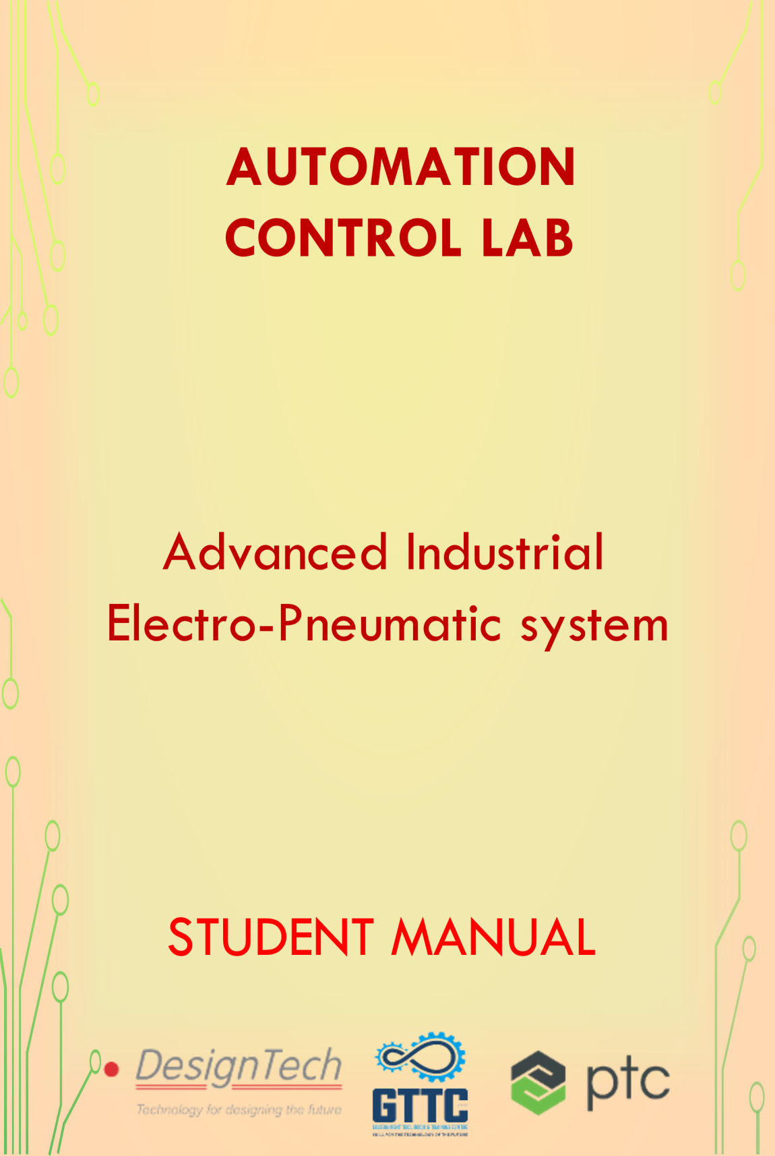

**AUTOMATION CONTROL LABO RATORY**

In this lab we use different types of Automation and control techniques, we will work on the different applications according to real-time industry scenarios. Understand the role of programmable logic controllers in complex mechatronic systems, modules, and subsystems.



The list of courses offered,

|  |  |  |  |
| --- | --- | --- | --- |
| S.No | Name of the Course | | Duration |
| 1 | | Basics of PLC | 50 Hours |
| 2 | | Basic SCADA | 50 Hours |
| 3 | | Industrial Level control and Batch Process Reactor System | 30 Hours |
| 4 | | Process Instrumentation Technology | 30 Hours |
| 5 | | Advance Process Control Techniques | 40 Hours |
| 6 | | Advanced Industrial Electro-Pneumatic System | 40 Hours |
| 7 | | Industrial Electro-Hydraulic System | 40 Hours |

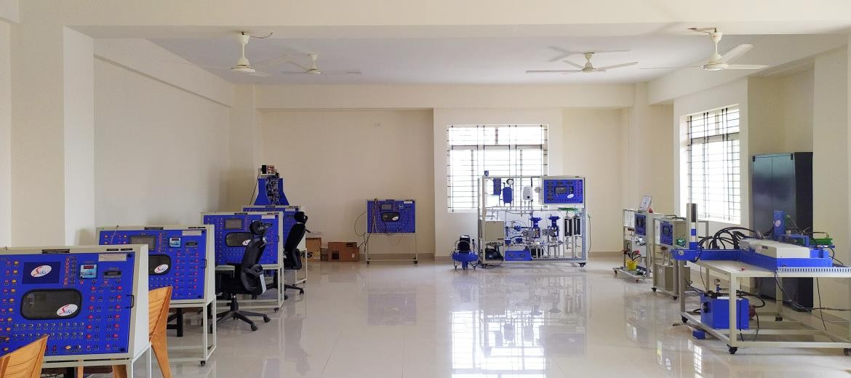

**Advanced Industrial Electro-Pneumatic System**

Pneumatic technology is found in numerous areas of engineering. Participants investigate the basic “building blocks” of modern Pneumatics and how they are interconnected to form systems.

This lab has an Electro-Pneumatic WorkStation i.e. designed to demonstrate the design, construction, and application of Pneumatic components and circuits.

The purpose of this laboratory is to train the participants to be familiar with the pneumatic hardware so that they can gain enough experience to meet the demand of the automation era.

|  |  |  |
| --- | --- | --- |
| S. No | Name of the Course | Duration |
| 1 | Advanced Industrial Electro-Pneumatic System | 40 Hours |

**Hardware Equipped**

* Different Types of Valves and Actuators
* Different types of Sensors
* Relays, Pneumatic equipment

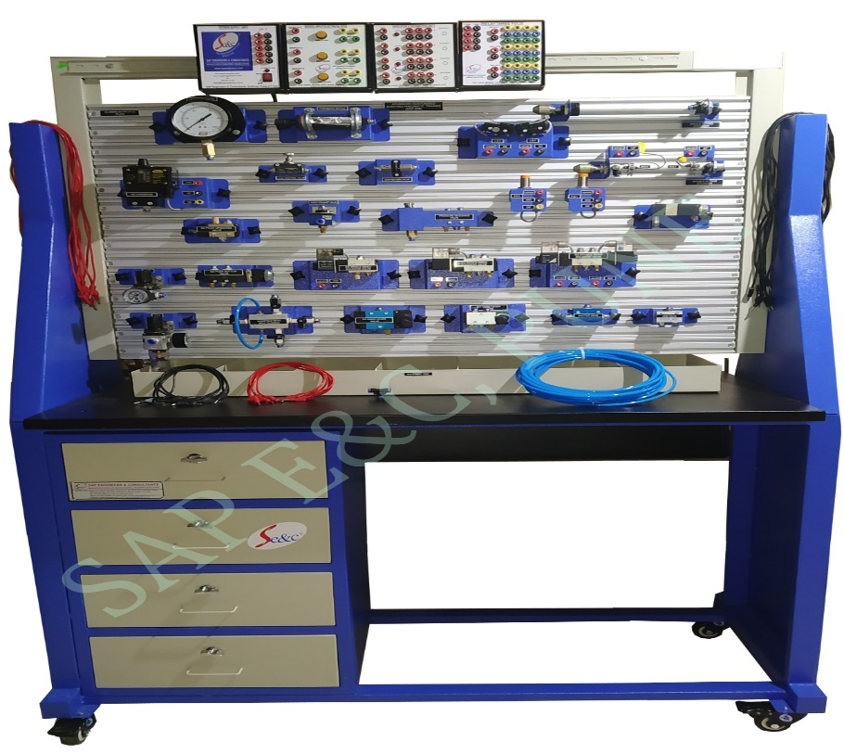

**Table of Contents**

**INTRODUCTION TO PNEUMATIC SYSTEM 10**

Pneumatic System 10

Electro-Pneumatic System Overview 11

Important Terms 11

Advantages of a Pneumatic System 12

Applications of Pneumatics 12

Basic components of Pneumatic 13

Actuators can be classified into three types. 14

1. Linear actuators 14

2. *Rotary actuators*: 14

Air Generation and Distribution 15

Selection of pipe diameter is governed by: 16

Pressure level 16

Air Compressor 16

Types of Compressor 17

Reservoirs 18

Air dryers 19

Low temperature drying 20

Air Service Unit 20

Filter 21

Regulator 22

Types of Regulation 22

Lubricator 23

**SYMBOLS AND STANDARDS IN PNEUMATIC SYSTEM 24**

Valves: 25

Methods of actuating a Valve 25

Manual actuated 25

Mechanically actuated 25

Pneumatic 25

Electrically actuated 25

Combined actuated 26

Methods of Return actuation 26

Non Return valves 26

Flow control valves 26

Directional control valves: ports and switching position 27

Pressure valve 27

Linear actuator 28

Linear actuator 28

Rotary actuator 29

Auxiliary Symbols 30

**DIRECTIONAL CONTROL VALVES: 31**

2/2-way valve 32

3/2-way valve 32

a) 3/2-way valve: disc seat normally closed, un-actuated 33

b) 3/2-way valve single pilot, normally closed, with spring return, actuated 34

3/2-way roller lever valve 35

4/2way valve 36

Actuation of the valve 36

a) 4/2 - way double pilot valve, longitudinal flat slide 37

b) 4/3way valve Cross Section 38

5/2-way valve 38

a) 5/2-way double pilot valve, suspended disc seat, flow from 1 to 2 39

b) 5/2-way double pilot valve, suspended disc seat, flow from 1 to 4 40

5/3-way valve 40

**COMPONENTS OF PNEUMATIC SYSTEM 41**

Non-Return Valve: 41

Check valves 41

Dual pressure valve (AND function) 41

Shutter valve (OR function) 42

Quick Exhaust Valve 43

Shut off Valve 43

Flow control valves 44

Throttle valve, bi-directional 44

One-way flow control valve 45

Pressure Valve 47

Pressure-regulating valve: 47

Pressure limiting valve: 47

Pressure sequence valve: 48

Combination valves 48

Time delay valve: normally closed 49

Time delay valve: normally open 50

Power component or Actuators 51

Single-acting cylinders 52

Double-acting cylinder 53

Rotary actuator 54

Control circuit for the single-acting cylinder 54

Control circuit for the double-acting cylinder 55

**DEVELOPMENT OF SINGLE ACTUATOR CIRCUIT 56**

Displacement-Step Diagram 56

Displacement-time diagram 57

Application example 57

Displacement-step diagram 58

Displacement-time diagram 59

Function chart 59

Structure of a function chart 60

Command field 60

Transition conditions 61

Directional control valve symbol development 61

Chain control 62

Electro-Pneumatic control system 63

Example 64

Design of the circuit diagram 64

Circuit layout Typical problem 65

Solution 66

Designation of individual elements 67

Actuated initial position 67

Designation by letters 68

Designation by letters 68

Analysis of a pneumatic control problem 69

Design 69

Implementation 69

Evaluation 70

Maintenance 70

System upgrade 70

**EXERCISE SESSION 71**

Draw the Pneumatic Circuit Diagram with Fluid Sim Software 71

Solution 71

**COMPONENTS AND ASSEMBLIES WITH ELECTRICAL SYSTEM 72**

Power supply unit 72

Change over contact 73

Switches 73

Switching contacts: 74

Limit Switches 75

Proximity switch Reed Switches 75

Electronic sensors 76

Inductive proximity Switch (sensors) 76

Capacitive Proximity Sensors 77

Optical proximity sensor 78

Reflective light barrier 79

Diffuse reflective optical sensor 79

Pressure sensor 80

Mechanical pressure switch 80

Electronic pressure switches 80

Analogue pressure sensors 81

Relay 82

Applications of relays 83

Retentive relay 83

Time relay 83

Functional principle 84

Contactor 84

Applications of contactors 85

Introduction to programmable logic controllers (PLCs) 85

Signal processing 87

Signal control section with programmable logic controller (PLC) 88

**EXERCISE SESSION 89**

Single Acting (Extension) cylinder sequencing: 91

Double Acting cylinder sequencing: 93

Electrical Circuit Diagram 95

Overview diagram 95

Function diagram 95

Circuit diagram 95

Electrical symbols 95

Graphical symbols of Electrical symbols 96

Graphical symbols for contactors: Manually operated switching devices 97

Graphical symbols for relay and contactor 99

Proximity Switches 100

Component Identification 101

**EXRSSICE SESSION 103**

Task 1 103

Exercise 103

Exercise description 103

Task 2 : sorting device 105

Exercise 105

Exercise description 105

Task 3: Training aims 106

Exercise 106

Exercise description 107

Position sketch 107

Task 4 Turning Device Training aim 108

Exercise 108

Exercise description 108

**ASSEMBLY SECTION 109**

Training Aim 109

Exercise 109

Exercise description 109

Solution Electrical solution 110

Diverting Device 111

Training aim 111

Exercise 111

Exercise description 111

**TASK SESSION 112**

Task 1: The Problem 112

Exercise 112

Positional sketch 112

Task 2 113

Training aims 113

Problem 113

**EXPERIMENT 114**

Experiment 1 114

Pneumatic Connection 114

Circuit diagram for single-acting cylinder using 3/2 solenoid valve 115

Operation: 115

Experiment 2 Study of AND gate 116

Procedure: 116

Experiment 3 Study of shut valve 118

Procedure: 118

Experiment 4 119

Procedure: 119

Experiment 5 120

Procedure: 120

Experiment 6 121

Procedure to connect the compressor to the AFR. 121

Experiment 7 122

Procedure: 122

Experiment 8 123

Experiment 8a 123

Procedure: 124

Experiment 8b 125

Procedure: 125

Experiment 8c 126

Procedure: 126

Experiment 9 127

Procedure: 127

Experiment 10 128

Electric connection 128

Procedure: 129

**DO’S AND DONT’S 130**

# INTRODUCTION TO PNEUMATIC SYSTEM

## Pneumatic System

* Pneumatics has long since played an important role as a technology in the performance of mechanical work. It is also being used in the development of automation solutions.
* Pneumatic systems are similar to hydraulic systems but in these systems compressed air is used in place of hydraulic fluid.
* A pneumatic system is a system that uses compressed air to transmit and control energy.
* Pneumatic systems are used extensively in various industries. Most pneumatic systems rely on a constant supply of compressed air to make them work.
* This is provided by an air compressor. The compressor sucks in air from the atmosphere and stores it in a high pressure tank called a receiver. This compressed air is then supplied to the system through a series of pipes and valves.
* The word Pneumatic means air. Pneumatics is all about using compressed air to do the work.
* Compressed air is the air from the atmosphere which is reduced in volume by compression thus increasing its pressure. It is used as a working medium normally at a pressure of 6 kg/sq mm to 8 kg/sq mm.
* For using pneumatic systems, maximum force up to 50 kN can be developed. Actuation of the controls can be manual, pneumatic, or electrical actuation. Compressed air is mainly used to do work by acting on a piston or vane. This energy is used in many areas of the steel industry.

## 

## Electro-Pneumatic System Overview

The electro-pneumatic action is a control system by the mean of air pressure for pipe organs, whereby air pressure, controlled by an electric current and operated by the keys of an organ console, opens and closes valves within wind chest, allowing the pipes to speak. This system also allows the console to be physically detached from the organ itself. The only connection was via an electrical cable from the console to the relay, with some early organ consoles utilizing a separate wind supply to operate combination pistons.

## Important Terms

* 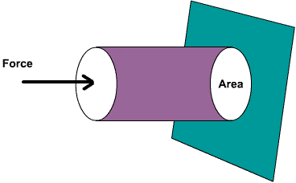**Pressure** is the force applied per unit area and the force applied is perpendicular to the area.



Application)

* **Gauge Pressure**-Gauge pressure is the pressure relative to atmospheric pressure.
* **Gauge pressure** is positive for pressures above atmospheric pressure, and negative for pressures below it.
* **Absolute Pressure**-Absolute pressure is the sum of gauge pressure and atmospheric Pressure.

## Advantages of a Pneumatic System

* Eco friendly
* Safe and easy to operate
* Abundant availability of Air
* Transport
* Explosion Proof
* Accurate operable Speed of air

## Applications of Pneumatics

* Automobile: Automobile industry use pneumatic systems for dismantling vehicle tire, filling compressed air in the tire, vehicle painting, opening and closing of doors, air brakes on heavy vehicles, etc.
* Used in the brake system of automobiles, railway coaches, wagons and printing presses.
* Transporting Goods: Pneumatics is used to transport goods from shelf to other location inside the company. The cylinder will push the item on the shelf into the moving belt if the button is pushed.
* Industrial Applications: Material handling, drilling, sawing, filling, packaging, clamping, shifting, etc. are some of the general applications of the pneumatic system.

## Basic components of Pneumatic

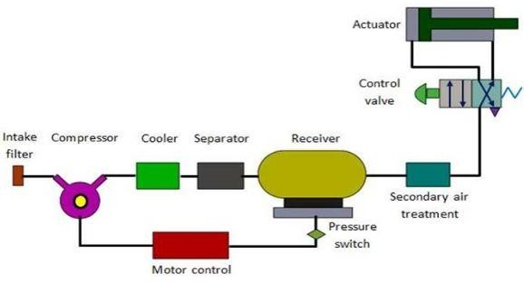

* **Air filters:** These are used to filter out the contaminants from the air.
* **Compressor:** Compressed air is generated by using air compressors. Air compressors are either diesel or electrically operated. Based on the requirement of compressed air, suitable capacity compressors may be used.
* **Air cooler:** During compression operation, air temperature increases. Therefore, coolers are used to reduce the temperature of the compressed air.
* **Dryer:** The water vapor or moisture in the air is separated from the air by using a dryer.
* **Control Valves:** Control valves are used to regulate, control and monitor for control of direction flow, pressure etc.
* **Air Actuator:** Air cylinders and motors are used to obtain the required movements of mechanical elements of pneumatic system.
* **Electric Motor:** Transforms electrical energy into mechanical energy. It is used to drive the compressor.
* **Receiver Tank:** The compressed air coming from the compressor is stored in the air receiver.
* **Actuators:** Actuators are output devices which convert energy from pressurized hydraulic oil or compressed air into the required type of action or motion. In general, hydraulic or pneumatic systems are used for gripping and/or moving operations in industry. These operations are carried out by using actuators.

## Actuators can be classified into three types.

1. 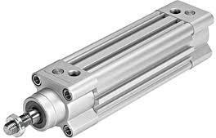Linear actuators***:***

These devices convert hydraulic/pneumatic energy into linear motion.

## **Rotary actuators***:*

These devices convert hydraulic/pneumatic energy into rotary motion. Actuators to operate flow control valves: these are used to control the flow and pressure of fluids such as gases, steam or liquid.

## Air Generation and Distribution

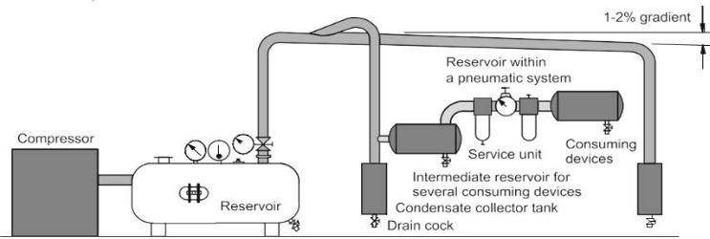

A number of aspects must be considered in the preparation of the service air.

* Quantity of air required to meet the demands of the system.
* Type of compressor to be used to produce the quantity required.
* Pressure requirements
* Storage required
* Requirements for air cleanliness
* Acceptable humidity levels to reduce corrosion and sticky operation
* Lubrication requirements
* Temperature of the air and effects on the system
* Line sizes and valve sizes to meet demand
* Material selection to meet environmental and system requirements
* Drainage points and exhaust outlets in the distribution system
* Layout of the distribution system to meet demand

## Selection of pipe diameter is governed by:

* Flow rate
* Pipe length
* Permissible pressure loss
* Operating Pressure
* Number of flow control points

## Pressure level

* As a rule, pneumatic components are designed for a maximum operating pressure of 800 to1000 kPa (8-10 bar).
* Practical experience has shown, however, that approximately 600 kPa (6 bar) should be used for economic operation.
* Pressure losses of between 10 and 50 kPa (0.1 and 0.5 bar) must be expected due to their striations, bends, leaks and pipe-runs, depending on the size of the piping system and method of layout.
* The compressor's system should provide at least 650 to 700 kPa (6.5 to 7 bar) for a desired operating pressure level of 600 kPa (6 bar).

## Air Compressor

* The task of the compressor is to compress the air to the required pressure and in the required volume. The engine consumes energy. The compressor transforms this energy and stores it as compressed air. Unfortunately, losses are severe. The screw compressor is the most common type.
* Piston compressors are used as well.
* An air compressor is a device that converts power using electric motor into potential energy stored in pressurized air called compressed air.
* Reciprocating (move backwards and forwards in a straight line) type air compressor is widely used in market. It has single or many stage type pistons. Which generate low air flow and high pressure.

## Types of Compressor

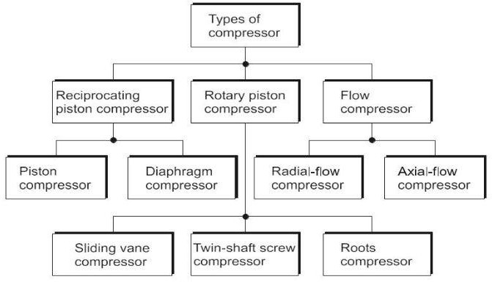

**Applications**

* For operating pneumatic tools such as drills, screw drivers, hammers, chisel
* For pneumatic cranes
* For pneumatic brakes of automobiles, railways and presses
* For agricultural accessories such as dusters and sprayers
* For drive of CNC machine tools
* For pneumatic conveying of materials
* For pneumatic gauging, inspection and low cost automation systems

## Reservoirs

* Tanks are used for storing compressed air temporarily. The storage guarantees that the demand can be covered securely. Often times you can find a condensate drain at the tank.
* The condensate can then drain off through a valve. The drain is actuated manually or automatically.
* The size of a compressed air reservoir depends on the:
* Delivery volume of the compressor
* Air consumption for the applications
* Network size (any additional requirements)
* Type of compressor cycle regulation
* Permissible pressure drop in the supply network

## Air dryers

* When air is compressed it loses its ability to hold water. Therefore, water remains when air is compressed.
* As this water, the condensate, would be disturbing the following processes, it needs to be removed from the pneumatic system. In a so called refrigeration dryer the water condensates and can be removed. There are also absorption dryers in which the water is absorbed by special materials.
* Condensate (water) enters into the air network through the air intake of the compressor.
* The accumulation of condensate depends largely on the relative air humidity. The relative air
* Humidity is dependent on the air temperature and the weather situation.
* The absolute humidity is the mass of water vapor, actually contained in one m3 of air.
* The following formula applies if the relative air humidity is specified in percent



## Low temperature drying

* The most common type of dryer today is the refrigeration dryer.
* The aim is to reduce the temperature of the air to a dew point which ensures that the water in the air condenses and drops out in the quantity required.

## Air Service Unit

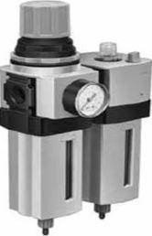

The service unit is a combination of the following

* Compressed Air Filter with water separator
* Compressed Air Regulator
* Compressed Air Lubricator

### Construction, Working Principle of FRL Unit, Dual (Twin) Pressure Valve, Shuttle Valve, Quick Exhaust Valve, Time Delay Valve ~ JK Just KnowhatFilter

* The air filter is integrated into the intake of the compressor. It prevents large, polluting particles on the outside from entering the air system. Through filtration, a major portion of unwanted particles can be kept out of the system.
* Filter is required to remove moisture, water vapor, Dust, and Rust from compressed air. Most of the tools and equipment has required clean air for long life operation.
* Dirty air enters the bowl through directional louvers, which create swirling air by c centrifugal action.
* Due to gravity, all water and dust particles fall down. Water collected at bottom side.
* Removed through automatic or manual drain assembly Regulator
* The output air pressure is regulated by turning the top knob.
* Knob gave the pressure on the spring and then diaphragm adjust the output pressure.

### How does an air pressure regulator works? - Pressure Measurement - Industrial Automation, PLC Programming, scada & Pid Control SystemRegulator

* + The output air pressure is regulated by turning the top knob.
  + Knob given the pressure on the spring and then diaphragm adjust the output pressure.

### Types of Regulation

In order to adapt the delivery quantity of the compressor to the fluctuating demand, I t is necessary to regulate the compressor

* + - Types of regulation
    - Idling regulation
    - Relief regulation
    - Shut-off regulation
    - Claw regulation
    - P art-load control Speed adjustment
    - Suction throttle control
    - Intermittent control

### FRL Unit - Function, Diagram, Construction, Working, Symbol, AdvantagesLubricator

Pneumatic components can be lubricated by using an airline lubricator, a device for adding lubricating oil in aerosol form into a compressed air line. The air passing through the lubricator transports the lubricant to air tools, cylinders or other air operated equipment.

Regulated air pressure flow down through nozzle and flow sensor

* + Due to pressure difference between oil reservoir and flow sensor, Oil flow up in siphon tube
  + Now lubricator air pressure passes to the tools and equipment Lubrication of the compressed air by means of mist lubricators may be necessary in certain cases:
* Where extremely rapid oscillating motions are required
* With cylinders of large diameter, lubricators should where possible be installed only directly upstream of the consuming cylinders

# SYMBOLS AND STANDARDS IN PNEUMATIC SYSTEM

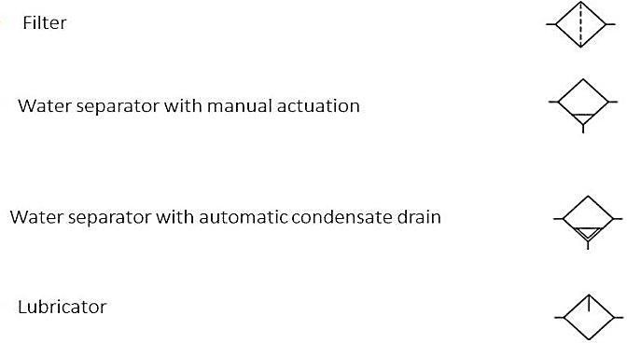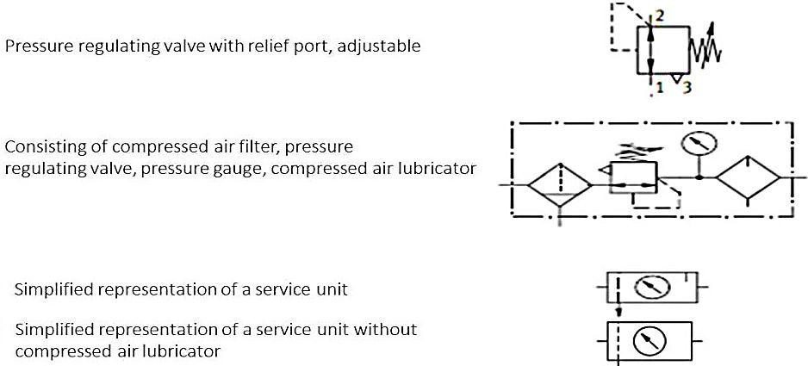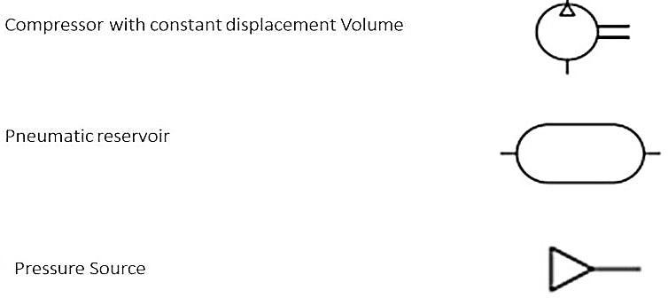

## Valves:

* The function of valve is to control pressure or flow rate of pressure media.
* Depending on the design, these can be divide into the following categories

## Methods of actuating a Valve

### Manual actuated

### Mechanically actuated

### Pneumatic

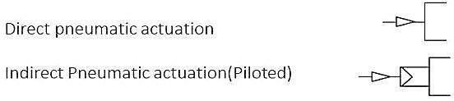

### Electrically actuated

### Combined actuated

### Methods of Return actuation

* + Spring return
  + Air Return

### Non Return valves

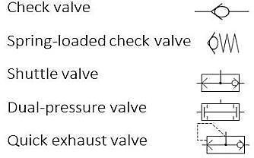

### Flow control valves

### Directional control valves: ports and switching position

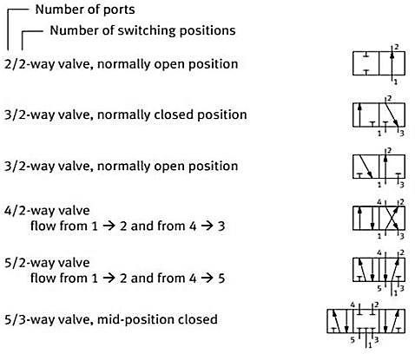

### Pressure valve

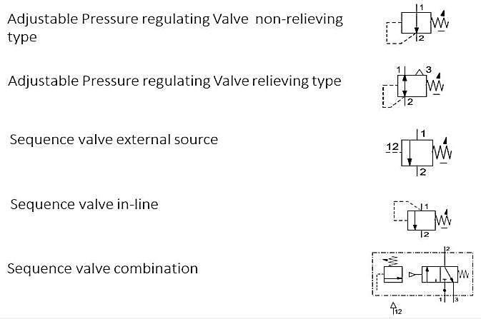

### Linear actuator

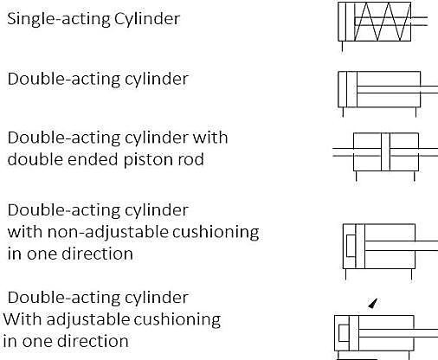

### Linear actuator

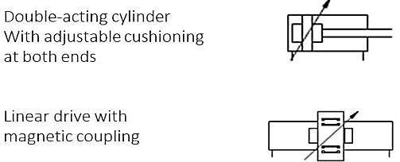

### Rotary actuator

## Auxiliary Symbols

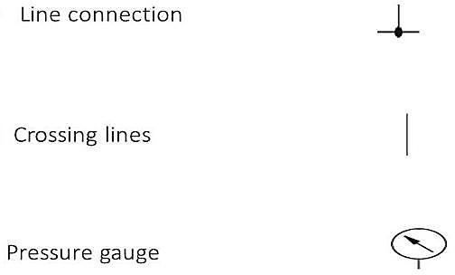

# DIRECTIONAL CONTROL VALVES:

* + Directional control valves are devices which influence the path taken by an air stream.
  + Normally this involves one or all of the following:
  + Opening the passage of air and directing it to particular air lines, canceling air signals as required by blocking their passage and/or relieving the air to the atmosphere via an exhaust port.
  + The directional control valve is characterized by its number of controlled connections or ways, the number of switching positions, and the method of actuation.
  + However, these symbols do not provide any information about the constructional design, but merely indicate the function of the valve.
  + The normal position on valves with existing reset, e.g. spring, refers to the switching position assumed by the moving parts of the valve if the valve is not connected.
  + The initial position is the switching position assumed by the moving parts of a valve after the valve has been installed in a system and the system pressure has been switched on and possibly also the electrical voltage, and with which the designated switching program starts.
  + The constructional principle of a directional control valve is an important factor as far as the service life, switching time, type of actuation, connection methods and size are concerned.
  + The directional control valve controls the passage of air signals by generating, canceling, or redirecting signals.]
  + DCVs are one of the most fundamental parts of pneumatic systems.
  + DCVs allow fluid flow (air) into different paths from one or more sources.
  + DCVs will usually consist of a spool inside a cylinder that is mechanically or electrically actuated.
  + The position of the spool restricts or permits flow, thus it controls the fluid flow.

## 

## 2/2-way valve

* + The 2/2-way valve has two ports and two positions (open, closed). It is rarely used except as an on-off valve, since its only function is to enable signal flow through and cannot release the air to atmosphere once in the closed position in contrast to the 3/2- way valve. The 2/2-way valve is normally of the ball seat construction.
  + This valve can be operated either manually, mechanically or pneumatically

## 3/2-way valve

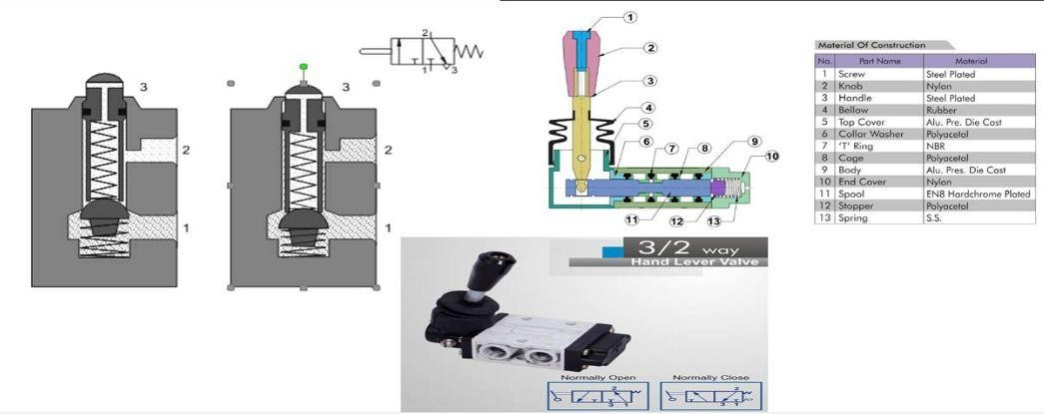

* + The 3/2-way valve has three ports and two positions. The addition of the exhaust port 3 enables the signal generated via the pas-sage through the 3/2-way valve to be cancelled.
  + The valve connects the output signal 2 to exhaust 3 and thus to atmosphere in the initial position.
  + A spring forces a ball against the valve seat preventing the com-pressed air from flowing from the air connection 1 to the working line 2.
  + Actuation of the valve plunger causes the ball to be forced away from the seat. In doing this, the opposing force of the reset spring and that generated from the compressed air must be overcome.
  + In the actuated state, connections 1 and 2 are connected and the valve is switched to flow. The valve is actuated either manually or mechanically. The actuation force required is dependent on the supply pressure, spring force, and friction in the valve. The actuation force limits the feasible size of the valve. The construction of the ball seat valve is very simple and compact

## 3/2-way valve: disc seat normally closed, un-actuated

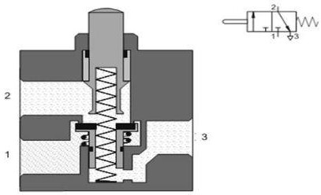

* + The valve shown above is constructed on the disc seat principle. The sealing is simple but effective. The response time is short and a small movement results in a large cross-sectional area being available for air flow. Like the ball seat valves, they are insensitive to dirt and thus have a long service life.
  + The 3/2-way valves are used for controls employing single-acting cylinders or for generating signals supplied to control elements.3/2-way valve: disc seat normally closed, actuated
  + A 3/2-way valve, in which the normal position is open to flow from 1 to 2, is referred to as a normally open valve.
  + Initially the 1 port is connected to the 2 port through the stem of the valve and the valve disc seat is closed at the 3 port. When the plunger is operated, the 1 air is initially blocked by the stem seat and then the disc is pushed off its seat to exhaust the output air to atmosphere via the passages 2 to 3.
  + When the plunger is released, the piston with the two sealing seats is returned to the initial position by the return spring. Once again the 3 port is blocked and air is supplied from 1 to2.
* The valves can be actuated manually, mechanically, electrically or pneumatically. Different actuation methods can be applied to suit the application.
* The pneumatically actuated 3/2-way valve is operated by an air signal at 12. The circuit diagram shown illustrates a pneumatically actuated valve with spring return in the normally closed position.
* Air applied at the 12 port moves the valve plunger against the reset spring. Connections 1 and 2 are connected. Upon release of the signal at port 12, the pilot spool is returned to the initial position by the return spring. The disc closes the connection between 1 and 2. The excess air in the working line 2 is exhausted through 3. The single-pilot 3/2-way valve with return spring can be configured as normally closed or as normally open.

## 3/2-way valve single pilot, normally closed, with spring return, actuated

* The pneumatically actuated valve can be used as a control element, when used in an indirect control.
* The signal for extension of the cylinder 1A is initiated indirectly by a push button 3/2-way valve 1S which sup-plies the control signal to the control element 1V.
  + 3/2-way valve, single pilot, normally open, un actuated for the normally open position, ports 1 and 3 only need to be inversely connected to the normally closed position.
  + The head of the valve with port 12 can be rotated 180°. The designation of the pilot port then is 10.
  + If a normally open valve is used at the position of valve 1V, then the cylinder is initially extended and upon operation of the push button of valve 1S, the cylinder retracts.

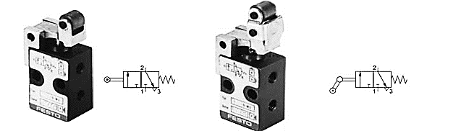

## 3/2-way roller lever valve

* + Piloted valves require only minimal actuating forces. A small hole connects the pressure connection 1 and the pilot valve. If the roller lever is operated, the pilot valve opens. Compressed air flows to the diaphragm and actuates the main valve disc. The first effect is the closing of the path 2 to 3 followed by the second disc seat opening the airway from 1 to 2.
  + The return position is effected by means of releasing the roller lever, thereby closing the pilot valve. The valve is exhausted via the hollow stem. The pilot piston of the main valve is returned to its initial position via the reset spring.
  + This type of valve can be used as either a normally closed valve or a normally open valve by changing ports 1 and 3 and by rotating the head 180°.
  + The roller lever valve with idle return only switches if the movement of the trip cam on the roller lever is in a certain direction. The valve is used a limit switch for the position sensing of the extended and retracted piston rod. Care should be taken to ensure that the valve is fitted in the correct direction of movement.
  + Likewise, this type of valve can be used either in the normally open or normally closed position. In the case of the normally open position, only ports 1 and 3 need to be inversely connected to the normally closed position. The head of the valve with roller lever actuator can be repositioned by 180

## 4/2way valve

The 4/2way valve has four ports and two positions. A disc-seat 4/2-way valve is similar in construction to the combination of two 3/2-way valves, one valve normally closed and the other normally open.

### Actuation of the valve

* + - When the two plungers are actuated simultaneously, 1 to 2 and 4 to 3 are closed by the first movement. By pressing the valve plungers further against the discs, opposing the reset spring force, the passages between 1 to 4 and from 2 to 3 are opened.
    - The valve has a non-overlapping exhaust connection and is returned to its start position by the spring. The valves are used for controls employing double-acting cylinders.
    - There are other actuating methods and types of construction available for the 4/2 - way valve including push button, single air pilot, double air pilot, roller lever-actuated, spool and sliding plate. In the main, the 4/2 - way valve is utilized in similar roles as the 5/2 – way valve.

## 4/2 - way double pilot valve, longitudinal flat slide

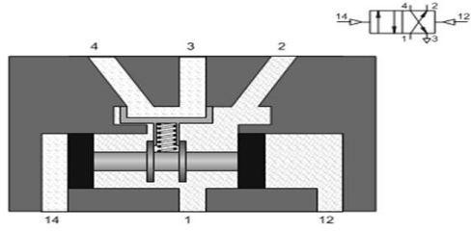

* The longitudinal flat slide valve has a control piston for the reversal of the valve. However, the lines are interconnected or separated from one another by means of an additional flat slide.
* The valve is reversed by means of direct pneumatic actuation. When the compressed air is removed from the control port, the control piston re - mains in the respective position until it receives a signal from the opposite control port.
* 4/3-way valve
* The 4/3- way valve has four ports and three positions. An example of the 4/3-way valve is the plate slide valve with hand or foot actuation. By turning two discs, channels are connected with one another.
* The 4/3-way valve has four ports and three positions. An example of the 4/3-way valve is the plate slide valve with hand or foot actuation. By turning two discs, channels are connected with one another.

## 4/3way valve Cross Section

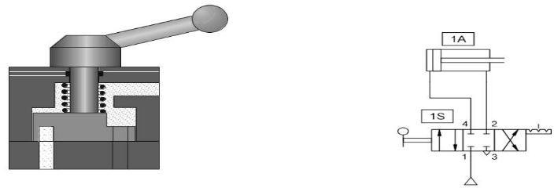

In this circuit diagram the lines of the 4/3-way valve are closed in the middle position. This enables the piston rod of a cylinder to be stopped in any position over its stroke range, although intermediate positions of the piston rod cannot be located with accuracy. Owing to the compressibility of air, another position will be assumed if the load on the piston rod changes.

## 5/2-way valve

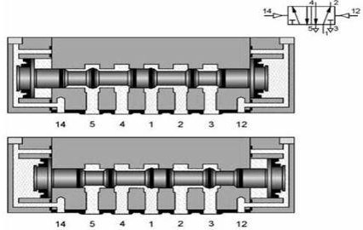

* + The 5/2-way valve has five ports and two positions. The 5/2-way valve is used primarily as a control element for the control of cylinders.
  + An example of the 5/2-way valve, the longitudinal slide valve, uses a pilot spool as a control component. This connects or separates the corresponding lines by means of longitudinal movements. The required actuating force is lower because there are no opposing forces due to compressed air or spring.
  + All forms of actuation can be used with longitudinal slide valves, i.e. manual, mechanical, electrical or pneumatic. These types of actuation can also be used for resetting the valve to its starting position.
  + The actuation travel is considerably larger than with seat valves. Sealing presents a problem in this type of slide valve. The type of fit known in hydraulics as metal to metal requires the spool to fit precisely in the bore of the housing.
  + In pneumatic valves, the gap between the spool and housing bore should not exceed

0.002 -0.004 mm, as otherwise, the leakage losses will be too great. To save these expensive fitting costs, the spool is often sealed with 0-rings or double-cup packing, or the bore of the housing is sealed with 0-rings. To avoid damaging the seals the connecting ports can be distributed around the circumference of the spool housing.

## 5/2-way double pilot valve, suspended disc seat, flow from 1 to 2

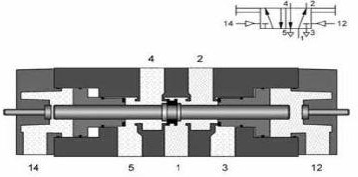

Another method of sealing is to use a suspended disc seat with relatively small switching movement. The disc seat seal connects the 1 port to either the 2 port or the 4 port. The secondary seals on the spool pistons close whichever exhaust port is not required. The valve in the diagram below has a manual override button at each end to manually operate the valve spool.

## 5/2-way double pilot valve, suspended disc seat, flow from 1 to 4

The 5/2-way double pilot valve has the characteristic of memory control. The valve is reversed from port 14 or 12 by means of reciprocal pneumatic signals. This new position is memorized until another unique signal occurs

## 5/3-way valve

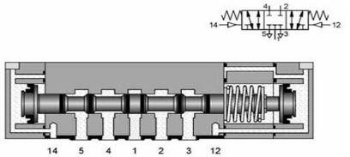

* + The 5/3-way valve has five working ports and three switching positions.
  + With these valves, double-acting cylinders can be stopped within the stroke range.
  + This means a cylinder-piston under pressure in mid-position is briefly clamped in the normally closed position and in the normally open position, the piston can be moved unpressurized.
  + If no signals are applied at either of the two control ports, the valve remains spring-centered in mid position

# COMPONENTS OF PNEUMATIC SYSTEM

## 

## Non-Return Valve:

### Check valves

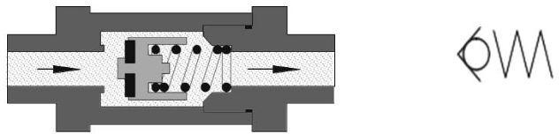

Check valves can stop the flow completely in one direction. In the opposite direction the flow is free with a minimal pressure drop due to the resistance of the valve. Blocking of the one direction can be effected by cones, balls, plates or diaphragms

### Dual pressure valve (AND function)

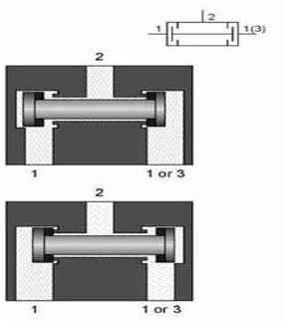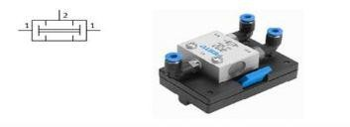

The dual-pressure valve is switched through (AND function) when signals are applied to both inputs 1. If different pressures are applied to the two inputs, then the lower pressure reaches output 2.

* + The dual pressure valve has two inlets 1 and 1(3) and one outlet A. Compressed air flows through the valve only if signals are applied to both inlets.
  + One input signal at 1 or 1(3) blocks the flow due to the differential forces at the piston slide. If signals are applied to both 1 and 1(3), the signal which is last applied passes to the outlet. If the input signals are of different pressures,

the larger of the two pressures closes the valve and the smaller air pressure is transferred to outlet 2.

* + The dual pressure valve is used mainly for interlocking controls, safety controls, check functions, and logic AND operations.
  + The dual pressure valve circuit is equivalent to the two input signaling devices in series, i.e. one after the other (3/2-way valve, normally closed position).

### Shutter valve (OR function)

A shutter permits the combination of two input signals into an OR function. The OR gate has two inputs and one output. An output signal is generate, if pressure is applied to one of the outputs.

* This non-return element has two inlets 1 and 1(3) and one outlet 2. If compressed air is applied to the first inlet 1, the valve seat seals the opposing inlet 1(3), and the air flows from 1 to 2. Inlet 1 is closed, if air passes from 1(3) to 2. A signal is generated at the outlet. When the air flow is reversed, i.e. a cylinder or valve is exhausted, the seat remains in its previously assumed position because of the pressure conditions.
* This valve is also called an OR element. If a cylinder or control valve is to be actuated from two or more positions, one or more shuttle valves should be used.
* In the example shown, a cylinder is to be advanced using two hand operated valves, which can be fitted at different distances from the cylinder. Without the use of the shuttle valve, the compressed air would mainly flow via port 3 of the valve 1S2, if the valve 1S1 is actuated.

## 

### Quick Exhaust Valve

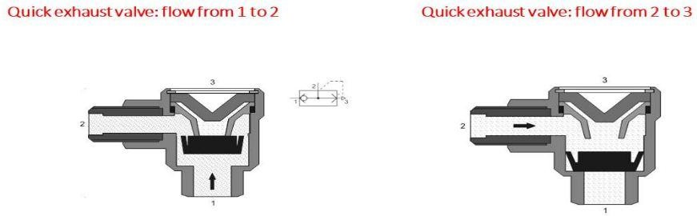

* + Quick-exhaust valves are used to increase the piston speed of cylinders. This enables lengthy return times to be avoided, particularly with single-acting cylinders.
  + The principle of operation is to allow the cylinder to re-tract at its near maximum speed by reducing the resistance to flow of the exhausting air during motion of the cylinder.
  + To reduce resistance, the air is expelled to atmosphere close to the cylinder via a large orifice opening. The valve has a closable supply connection 1, a closable exhaust 3 and an outlet 2.

### Shut off Valve

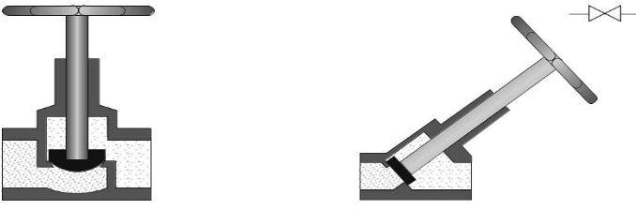

Shut-off valves are non-adjustable valves, which release or shut off flow in both directions. Typical examples are the stop cock and ball cock.

### Flow control valves

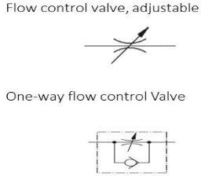

Flow control valve restrict the flow or throttle the air in particular direction to reduce the flow rate of air and hence control the signal flow.

* Flow control valves influence the volumetric flow of the compressed air in both directions. The throttle valve is a flow control valve.
* The flow control valve restricts or throttles the air in a particular direction to reduce the flow rate of the air and hence control the signal flow.

### Throttle valve, bi-directional

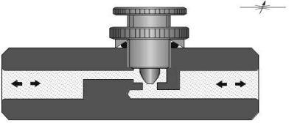

Throttle valves are normally adjustable and the setting can be locked in position. Throttle valves are used for speed control of cylinders. Care must be taken that the throttle valve does not close fully, cutting off air from the system Characteristics of flow control valves according to construction principle:

* + Throttle valve: In the throttle valve, the length of the throttling section is greater than its diameter.
  + Diaphragm valve: In the diaphragm valve, the length of the throttling section is less than its diameter.

### One-way flow control valve

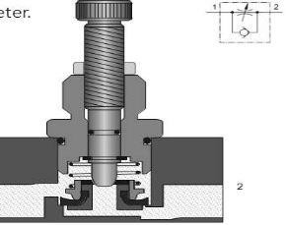

In the case of the one-way flow control valve, the air flow is throttled in one direction only. A check valve blocks the flow of air in the bypass leg and the air can flow only through the regulated cross-section. In the opposite direction, the air can flow freely through the opened check valve. These valves are used for speed regulation of actuators and if possible, should be mounted directly on the cylinder.

Fundamentally, there are two types of throttling circuits for double-acting cylinders:

#### Supply air throttling:

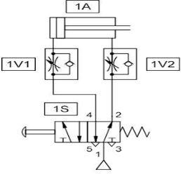

* For supply air throttling, one-way flow control valves are installed so that the air entering the cylinder is throttled. The exhaust air can escape freely through the check valve of the throttle valve on the outlet side of the cylinder. The slightest fluctuations in the load on the piston rod, such as occur for example when passing a limit switch, lead to very large irregularities in the feed speed
* A load in the direction of movement of the cylinder accelerates the cylinder beyond the set value. Therefore, supply air throttling can be used for single-acting and small volume cylinders.

#### Exhaust air throttling:

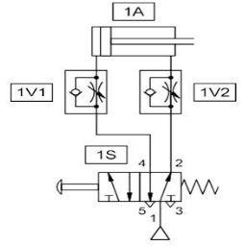

* With exhaust air throttling, the supply air flows freely to the cylinder and the exhaust air is throttled. In this case, the piston is loaded between two cushions of air. The first cushion effect is the supply pressure to the cylinder and the second cushion is the exhausting air being restricted at the one-way flow control valve orifice.
* Arranging throttle relief valves in this way contributes substantially to the improvement of feed behavior. Exhaust air throttling should be used for double-acting cylinders. In the case of miniature cylinders, supply and exhaust air flow control is to be selected because of the reduced air quantity.

#### Mechanically adjustable Two valve control:

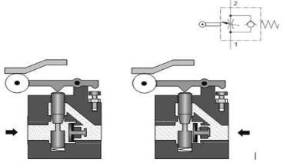

* With mechanically adjustable one-way flow control valves, the speed of the cylinder can be changed during the stroke.
* The basic speed can be set via an adjusting screw. By means of an irregular shaped follower, which actuates the roller lever of the mechanically adjustable one-way flow control valve, the throttle cross section is correspondingly changed.

## Pressure Valve

Pressure control valves are elements which predominantly influence the pressure or are controlled by the magnitude of the pressure. They are divided into the three groups:

### Pressure-regulating valve:

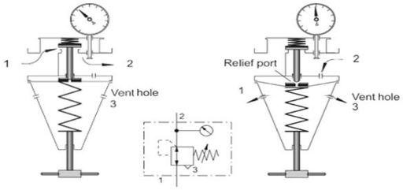

The pressure regulating valve is dealt with under section B 2.6 ―Service unit‖. The role of this unit is to maintain constant pressure even with fluctuating supply. The input pressure must be greater than the required output pressure.

### Pressure limiting valve:

The pressure limiting valves are used mainly as safety valves (pressure relief valves). They prevent the maximum permissible pressure in a sys-tem from being exceeded. If the maximum pressure has been reached at the valve inlet, the valve outlet is opened and the excess air pressure exhausts to atmosphere. The valve remains open until it is closed by the built-in spring after reaching the pre-set system pressure.

### Pressure sequence valve:

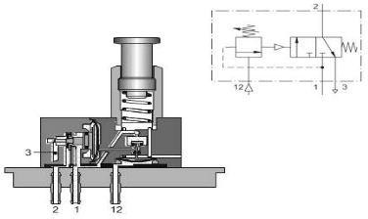

The principle on which this valve acts is the same as for the pressure limiting valve. If the pressure exceeds that set on the spring, the valve opens. The flow from 1 to 2 is closed.

Outlet 2 is opened only if a pre-set pre-sure has built up in pilot line 12. A pilot spool opens the passage 1 to 2

### Combination valves

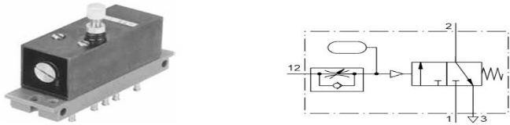

Time delay valve Combined functions of various elements can produce a new function. An example is the time delay valve which is the combination of a one-way flow control valve, a reservoir and a 3/2-way directional control valve.

## Time delay valve: normally closed

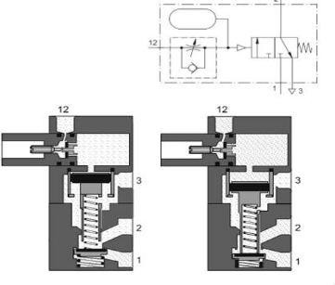

* The time delay valve is a combined 3/2-way valve, one-way flow control valve, and air reservoir. The 3/2-way valve can be a valve with a normal position open or closed. The delay time is generally 0-30 seconds for both types of valves
* The compressed air is supplied to the valve at connection 1. The control air flows into the valve at 12 through a one-way flow control valve and depending on the setting of the throttling screw, a greater or lesser amount of air flows per unit of time into the air reservoir.
* When the necessary control pressure has built up in the air reservoir, the pilot spool of the 3/2-way valve is moved downwards.
* This blocks the passage from 2 to 3. The valve disc is lifted from its seat and thus air can flow from 1 to 2. The time required for the pressure to build up in the air reservoir is equal to the control time delay of the valve.
* If the time delay valve is to switch to its initial position, the pilot line 12 must be exhausted. The air flows from the air reservoir to the atmosphere through the bypass of the one-way flow control valve and then to the exhaust line. The valve spring returns the pilot spool and the valve disc seat to their initial positions. Working line 2 exhausts to 3and 1 is blocked.

## Time delay valve: normally open

* The normally open time delay valve includes a 3/2-way valve which is open. Initially the output 2 is active. When the valve is switched by 10 the output 2 is exhausted to 3 and 1 is closed. The result is that the out-put signal is turned off after a set time delay
* The time delay corresponds to the pressure build up in the reservoir again. If the air at port 10 is removed, then the 3/2-way valve assumes the normal position.
* The circuit below utilizes two-time delay valves, one a normally closed valve (1V2) and the other a normally open valve (1V1). Upon operation of the start button 1S1, the signal generated passes through the valve 1V1 and initiates the movement of cylinder extension (1A) via the 14 port of the control element 1V3. The time delay valve 1V1 has a short time delay set of 0.5 seconds. This is long enough to initiate the start signal but then the 14 signal is cancelled by the 10 pilot signal of the time delay valve. The cylinder operates limit valve 1S2. The time delay valve 1V2 receives a pilot signal which after the pre-set time opens the valve. This supplies the 12 signal which reverses the valve and retracts the cylinder. A new cycle can only be started via the start button and renewed actuation of the valve1S1.

## Power component or Actuators

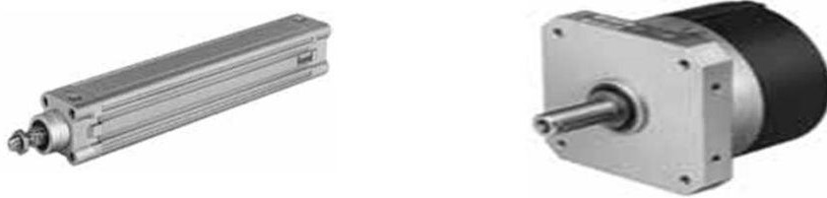

The power section consists of control elements and power components or actuators. The actuator group includes various types of linear and rotary actuators of varying size and construction. The actuators are complemented by the control elements, which transfer the required quantity of air to drive the actuator. Normally this valve will be directly connected to the main air supply and fitted close to the actuator to minimize losses due to resistance. Actuator with the control element

Actuators can be further broken down into groups:

* + Linear actuators–

Single acting cylinder

Double-acting cylinder

* + Rotary actuators

Air motors

Rotary actuators

* + An actuator is an output device for the conversion of supply energy into useful work. The output signal is controlled by the control system, and the actuator responds to the control signals via the control element. Other types of output devices are used to indicate the status of the control system or actuators, e.g. a pneumatically actuated visual display.

The pneumatic actuator can be described under two groups,

* + Linear motion

Single acting cylinders Double-acting cylinders

* + Rotary motion

Air motor Rotary Cylinders Rotary actuator

## Single-acting cylinders

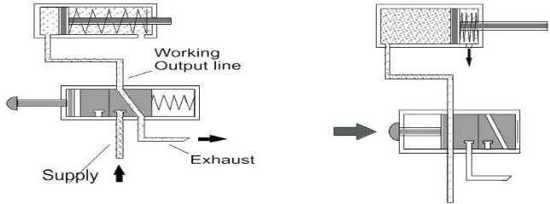

* A single-acting cylinder in a reciprocating engine is a cylinder in which the working fluid acts on one side of the piston only. A single-acting cylinder relies on the load, springs, other cylinders, or the momentum of a flywheel, to push the piston back in the other direction. Single-acting cylinders are found in most kinds of reciprocating engine. They are almost universal in internal combustion engines (e.g. Petrol and diesel engines) and are also used in many external combustion engines such as Sterling engines and some steam engines. They are also found in pumps and hydraulic rams.



* With single-acting cylinders compressed air is applied on only one side of the piston face. The other side is open to atmosphere. The cylinder can produce work in only one direction. The return movement of the piston is effected by a built-in spring or by the application of an external force. The spring force of the built-in spring is designed to return the piston to its start position with a reasonably high speed under no load conditions.

## Double-acting cylinder

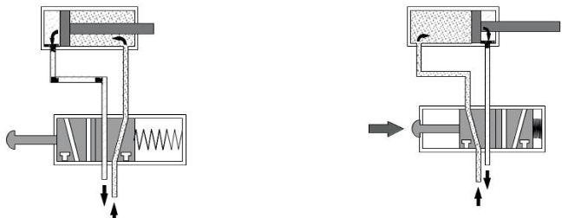

* The construction principle of a double-acting cylinder is similar to that of the single- acting cylinder. However, there is no return spring, and the two ports are used alternatively as supply and exhaust ports. The double-acting cylinder has the advantage that the cylinder is able to carry out work in both directions of motion. Thus, installation possibilities are universal. The force transferred by the piston rod is somewhat greater for the forward stroke than for the return stroke as the effective piston surface is reduced on the piston rod side by the cross-sectional area of the piston rod.

## Rotary actuator

* With a rotary actuator, force is transmitted direct to the drive shaft via a vane. Angular displacement is infinitely adjustable from 0o to approx. 180o. Torque should not exceed 10 Nm. Design features of pneumatic rotary actuators:
  + Small and robust
  + Available with contactless sensing
  + Adjustable for angular displacement
  + Easy to install

## Control circuit for the single-acting cylinder

The piston rod of a single-acting cylinder is to advance when a push button is operated. When the push button is released, the piston is to automatically return to the initial position.

Solution:

A 3/2-way valve controls the single-acting cylinder. The valve switches from the initial position into the flow position, when the push-button actuator is pressed. The circuit includes the following primary features:

* Single-acting cylinder, spring return
* 3/2-way directional control valve: push button for operation and spring for return force
* Supply air source connected to the 3/2-way valve
* Air connection between valve and cylinder

Note: Draw Circuit diagram with Fluid sim Software.

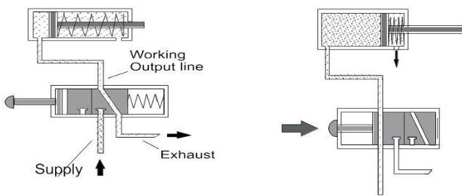

## Control circuit for the double-acting cylinder

The piston rod of a double-acting cylinder is to advance when a push button is operated and to return to the initialize position when the push but- ton is released. The double-acting cylinder can carry out work in both directions of motion, due to the full air supply pressure being available for extension and retraction.

Solution

* A5/2-way directional control valve controls the double acting cylinder. A signal is generated or reset on the valve, I push-button actuator is pressed or released. The circuit includes:
* Double-acting cylinder
* 5/2-way directional control valve: push button for operation and spring for return force
* Supply air source connected to the 5/2-way valve
* 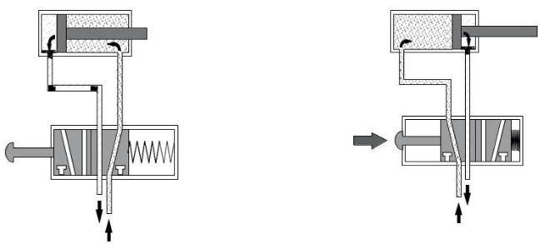Air connections between valve and cylinder

# DEVELOPMENT OF SINGLE ACTUATOR CIRCUIT

## Displacement-Step Diagram

In order to develop control circuitry for multi-cylinder applications, it is necessary to draw the displacement step diagram to understand the sequence of actuation of various signal input switches, limit switches, and sensors. The displacement step diagram represents the status of cylinder position whether extended or retracted in a particular step.

The movements of the piston rods are shown in the displacement step diagram. The individual movement steps are numbered consecutively from the left to right. If there is more than one power component, the movements of the piston rods are plotted one below the other. This diagram illustrates how the various movements follow each other.

## Displacement-time diagram

In a displacement-time diagram, the movements of the piston rods are plotted as a function of time. This form of representation highlights the different lengths of time needed for individual steps. The displacement-time diagram for the sheet-metal bending device (Fig.) shows that advancing the piston rod of cylinder 2A (step 2) takes considerably longer than retracting it (step 3).

## Application example

* + A sheet-metal bending device (in the below figure) has two double-acting pneumatic cylinder drives that are actuated with spring-return 5/2-way valves.
  + Cylinder 1A is used to clamp the workpiece. Proximity switches 1B2 (forward end position) and 1B1 (retracted end position) and a 5/2-way valve with solenoid coil 1M1 are assigned to this cylinder.
  + Cylinder 2A (forward end position: proximity switch 2B2, rear-end position: proximity switch 2B1, 5/2-way valve with solenoid coil 2M1) executes the bending process.
  + Four steps are required for the bending operation
  + Advance piston rod of cylinder 1A (clamp work piece)
  + Advance piston rod of cylinder 2A (bend metal sheet)
  + Retract piston rod of cylinder 2A (retract bending
  + Retract piston rod of cylinder 1A (release work piece)

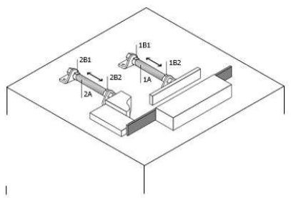

## Displacement-step diagram

The movements of the piston rods are shown in the displacement-step diagram. The individual movement steps are numbered consecutively from left to right. If there is more than one power component, the movements of the piston rods are plotted one below the other This diagram illustrates how the various movements follow on from each other

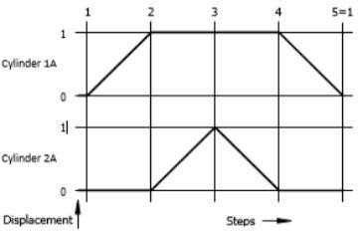

## Displacement-time diagram

In a displacement-time diagram the movements of the piston rods are plotted as a function of time. This form of representation highlights the different lengths of time needed for individual steps. The displacement-time diagram for the sheet-metal bending device shows that advancing the piston rod of cylinder 2A (step 2) takes considerably longer than retracting it (step 3).

## Function chart

A function chart in accordance with DIN/EN40719/6 can be used for graphical representation of a control system irrespective of the technology used. Function charts are used in many fields of automation for planning and documenting sequence controls, for example in power stations, industrial process engineering facilities, or material flow systems.

## Structure of a function chart

Function charts have a sequence-oriented structure. They comprise the following

* + Representation of the steps in the sequence by step fields and command fields
  + 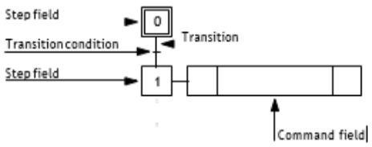Representation of transitions by connection lines and transition conditions

Step field

Each step field is numbered in accordance with the sequence. The initial state of the sequence (basic setting of the control system) is identified by a step field with a double frame.

## Command field

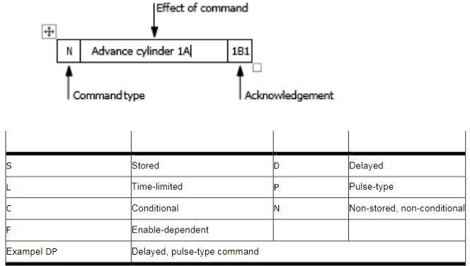

* The nature of the command is shown in the left-hand part. Non-storing(N), for example

means that the output is actuated for this step only. Table6.1 gives an overview of the possible types of commands

* The effect of the command, for example, to advance a cylinder drive is shown in the central part.
* The feedback signal acknowledging the execution of the command is entered in the right-hand part (for example in the form of a number or by specifying the corresponding sensor).

## Transition conditions

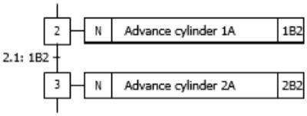

The transition from one step to the next does not take place until the associated transition condition has been satisfied. In order to improve the overall clarity of the function chart , the transition conditions are numbered. The numbering refers to the step and the command whose acknowledgment is evaluated

## Directional control valve symbol development

## 

**Development of pneumatic systems**

The circuit diagram should be drawn using standard symbols and labelling. Comprehensive documentation is required including most of the following

* + Function diagram
  + Circuit diagram
  + Description of the operation of the system
  + Technical data on the components

## Chain control

* + The control chain is a categorized representation of a control system, from which amongst other things, the signal direction can be determined.
  + With the circuit design, the system breakdown produces a rough separation of signal Input, signal processing, signal output and command execution. In practice, this separation can be easily seen. In the case of extensive installations, the control section is generally in a separate area to that of the power section.
  + The signal flow diagram indicates the path of a signal from signal input through to command execution.

## Electro-Pneumatic control system

**Comparison of process between Electric and Pneumatic System**

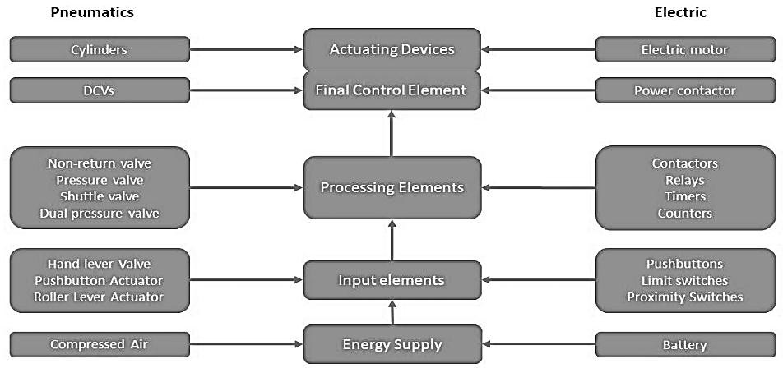

## Example

The illustration below clearly shows the structure of the control chain.

* + The input elements are the manually actuated valves 151, 152 (push-button valves), and the mechanically actuated valve 153 (roller lever valve).
  + The processing element (processor) is the shuttle valve 1V1,
  + The control element is the directional control valve 1V2.
  + 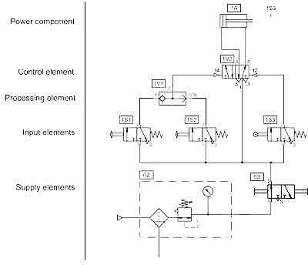The power component is cylinder 1A.

## Design of the circuit diagram

* + The structure of the circuit diagram should correspond to the control chain, whereby the signal flow is represented from the bottom to the top. Simplified or detailed symbols may be used for the representation of the circuit diagram. In the case of larger circuit diagrams, the power supply parts (service unit, shut-off valve, various distributor connections) are shown on a separate page of the drawing for the purpose of simplification.

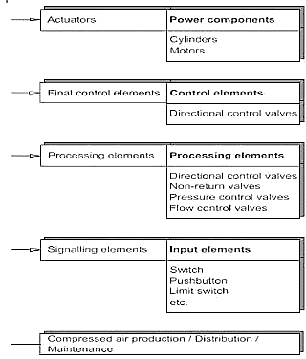

If a circuit diagram is represented in this schematic form, this is known as a circuit diagram. Irrespective of the actual tubing connections of the installation, the circuit diagram structure is always the same.

## Circuit layout Typical problem

* + The piston rod of a double-acting pneumatic cylinder advances if either a manual push button or a foot pedal is operated.
  + 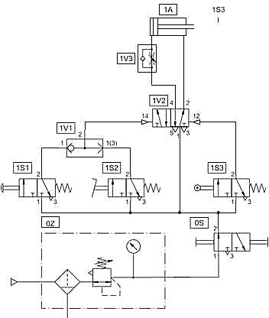The cylinder returns to its starting position slowed down after fully ex-tending. The piston rod will return provided the manual actuators have been released.

## Solution

* + The roller lever valve 1S3 is positioned as a limit switch in the forward end position of the cylinder. The circuit diagram shows this element situated at the signal input level and does not directly reflect the orientation of the valve. The mark on the circuit at the extended cylinder position indicates the physical position of the limit switch 1S3 for circuit operation.
  + If the control is complex and contains several working elements, the control should be broken down into separate control chains, whereby a chain is formed for each cylinder.
  + Wherever possible, these chains should be drawn next to each other in the same order as the operating sequence.

## Designation of individual elements

* + Signal elements should be represented in the normal position in the circuit diagram. If valves are actuated in the initial position as a start pre-condition, this must be indicated by the representation of a trip cam. In this case, the actuated switching position must be connected.
  + Signal elements should be represented in the normal position in the circuit diagram.
  + If valves are actuated in the initial position as a start pre-condition, this must be indicated by the representation of a trip cam

## Actuated initial position

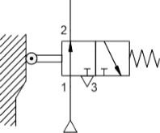

**Designation by numbers**

* + With this type of designation, elements are divided into groups. Group 0 contains the elements for the power supply, groups 1,2,... designate the individual control chains. One group number is generally allocated for each cylinder.

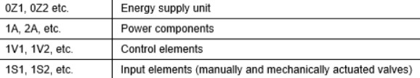

## Designation by letters

* + This type of designation is used primarily for a systematic development of circuit diagrams. Here, limit switches are allocated to the cylinder, which acknowledges them.

## Designation by letters

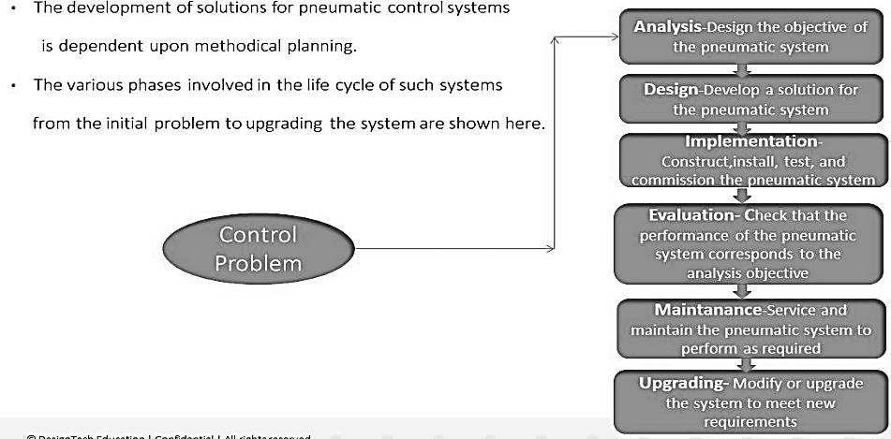**The life cycle of a pneumatic system**

## Analysis of a pneumatic control problem

* + The first step is the definition of objectives for the project with a clear definition of the problem(s). Design or development of the solution is not involved at the analysis stage. A flow chart of the total project plan can be developed to define the step- orientated processes.

## Design

* + There are two stages of design development. The first is the overall system design where general systems hardware and control medium decisions are made. At this stage alternative solutions may be addressed for consideration.

The next stage of the design process involves the following:

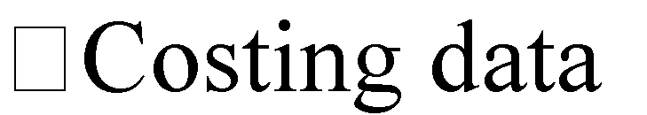

## Implementation

* + Prior to the system installation, the system's functions must be fully tested. Another function test must be carried out on the final completion of the installation. Finally to ensure the sequence operates under all conditions, the machine must be cycled under all of the expected and specified operating conditions, e.g. manual cycle, auto cycle, emergency conditions, blockages etc

## Evaluation

* + Upon completion of the commissioning process the final result is evaluated and compared to the original specification and if necessary improvements are made.

## Maintenance

* + Maintenance is essential to minimize the system downtimes. Regular and careful maintenance helps to increase the reliability of a system and to reduce the operating costs. After a certain number of cycles, some components may show signs of early deterioration which might be due to
    - incorrect product selection or
    - a change in operating conditions.

Basic preventive maintenance carried out at regular intervals helps to diagnose failures of this kind and thus avoids system downtimes

## System upgrade

* + Experience gained from the operation, maintenance and repairing of a system, will ensure greater reliability in the event of any system improvements.

# EXERCISE SESSION

## Draw the Pneumatic Circuit Diagram with Fluid Sim Software

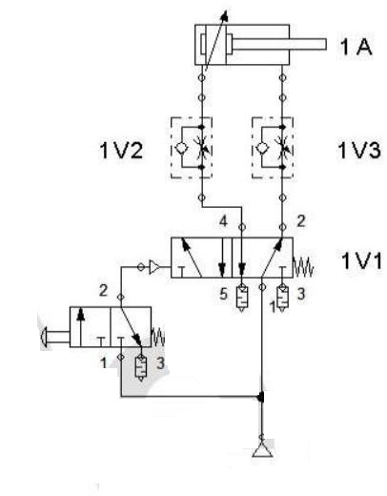

1. Double Acting cylinder with adjustable end cushioning at both end, direct control by 5/2 way DCV with direct pneumatic actuation (through 3/2 way DCV push button operated with spring returned, normal closed), spring returned.

## Solution

1. Double Acting cylinder with adjustable end cushioning at both end, direct control by 5/2 way DCV with selection switch, spring returned, pneumatic speed adjustment by one way FCV with outlet throttle on both side.
2. Double Acting cylinder with adjustable end cushioning at both end, direct control by 5/2 way DCV with selection switch, spring returned, pneumatic speed adjustment by one way FCV with inlet throttle on both side.

# COMPONENTS AND ASSEMBLIES WITH ELECTRICAL SYSTEM

## Power supply unit

* + The signal control section of an electro pneumatic controller is supplied with power via the electrical mains. The controller has a power supply on it forth is purpose. The individual assemblies of the power supply unit have the following tasks:
  + The transformer reduces the operating voltage. The mains voltage (i.e.230V) is applied to the input of the transformer. A lower voltage (i.e.24V) is available at the output.
  + The rectifier converts the AC voltage into DC voltage. The capacitor at the rectifier output smooth the voltage.
  + The voltage regulator at the output of the power supply unit is required to ensure that the electrical voltage remains constant regardless of the current flowing.

## 

## Change over contact

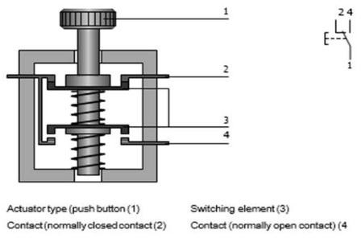

* + The changeover contact combines the functions of the normally open and normally closed contacts in one device. Change over contacts is used to close one circuit and open another in one switching operation. The circuits are momentarily interrupted during the changeover.

## Switches

* + In electrical engineering, a switch is an electrical component that can make or break an electrical circuit, interrupting the current or diverting it from one conductor to another. The mechanism of a switch may be operated directly by a human operator to control a circuit (for example, a light switch or a keyboard button), may be operated by a moving object such as a door operated switch, or may be operated by some sensing element for pressure, temperature or flow. A relay is a switch that is operated by electricity. Switches are made to handle a wide range of voltages and currents.
  + The most familiar form of switch is a manually operated electromechanical device with one or more sets of electrical contacts, which are connected to external circuits. Each set of contacts can be in one of two states: either "closed" meaning the contacts are touching and electricity can flow between them, or "open", meaning the contacts are separated and electricity cannot flow between them. The mechanism actuating the transition between these two states (open or closed) can be either a "toggle" (flip switch for continuous "on" or "off") or "momentary" (push for "on" or push for "off") type.

## Switching contacts:

* + In the simplest case, a switch has two conductive pieces, often metal, called contacts, connected to an external circuit, that touch to complete (make) the circuit, and separate to open (break) the circuit.
  + In electronics, switches are classified according to the arrangement of their contacts. A pair of contacts is said to be "closed" when current can flow from one to the other. When the contacts are separated by an insulating air gap, they are said to be "open", and no current can flow between them at normal voltages. The terms "make" for closure of contacts and "break" for opening of contacts are also widely used.
  + The terms pole and throw are also used to describe switch contact variations. The number of "poles" is the number of electrically separate switches which are controlled by a single physical actuator. For example, a ―2-pole‖ switch has two separate, parallel sets of contacts that open and close in the same mechanism. The number of "throws" is the number of separate wiring path choices other than "open" that the switch can adopt for each pole. A single throw switch has one pair of contacts that can either be closed or open.

## Limit Switches

* + A limit switch is actuated when a machine part or work piece is in a certain position. Normally, actuation is affected by a cam. Limit switches are normally changeover contacts. They can then be connected — as required-as a normally open contact, normally closed contact changeover contact.

## Proximity switch Reed Switches

* + The reed switch/contact is an electrical switch operated by an applied magnetics field.it consists of a pair of contacts on ferrous metal reeds in a hermetically sealed glass envelope.
  + The contacts may be normally open, and closing when a magnetic field is present, or normally closed and opening when a magnetic field is applied. The switch may be actuated by a coil, making a reed relay, or by bringing a magnet near

to the switch. Once the magnet is pulled away from the switch, the reed switch will go back to its original position. Figure: Reed switch contacts

* + Reed switches are small in size, which makes them easy to mount and unobtrusive, and the fact that the operating force required to operate the switch is very small. Reed switches, and suitable magnets, are also cheap and easily obtainable.

## Electronic sensors

Inductive, optical and capacitive proximity switches are electronic sensors. They normally have three electrical contacts.

* + Contact for supply voltage
  + Contact for ground
  + Contact for output signal
  + In these sensors, no movable contact is switched. Instead, the outputs either electrically connected to the supply voltage or to ground (= output voltage 0V). Positive and negative switching sensors there are two types of electronic sensor with regard to the polarity of the output voltage.
  + In positive switching sensors, the output voltage is zero if no part is detected in the proximity. The approach of a work piece or machine part leads to switchover of the output, applying the supply voltage.
  + In negative switching sensors, the supply voltage is applied to the output if no part is detected in the proximity. The approach of a work piece or machine part leads to switchover of the output, switching The output voltage to V.

## Inductive proximity Switch (sensors)

* + An inductive proximity sensor is a type of non-contact electronic proximity sensor that is used to detect the position of metal objects.
  + The sensor incorporates an electromagnetic coil which is used to detect the presence of a conductive metal object
  + The sensor will ignore the presence of an object if it is not metal. When a metal target enters the field, eddy currents circulate within the target.
  + This causes a load on the sensor, decreasing the amplitude of the electromagnetic field. As the target approaches the sensor the eddy currents increase, increasing the load on the oscillator and further decreasing the amplitude of the field.
  + The trigger circuit monitors the oscillator’s amplitude and at a predetermined level switches the output state of the sensor from its normal condition (on or off). As the target moves away from the sensor, the oscillator’s amplitude increases
  + At a predetermined level the trigger switches the output state of the sensor back to its normal condition (on or off).

## 

## Capacitive Proximity Sensors

* + Capacitive proximity sensors are similar to inductive proximity sensors. The main difference between the two types is that capacitive proximity sensors produce an electrostatic field instead of an electromagnetic field. Capacitive proximity switches will sense metal as well as non-metallic materials such as paper, glass, liquids, and cloth.
  + 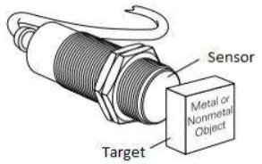The sensing surface of a capacitive sensor is formed by two concentrically shaped metal electrodes of an unwound capacitor. When an object nears the sensing surface it enters the electrostatic field of the electrodes and changes the capacitance in an oscillator circuit. As a result, the oscillator begins oscillating. The trigger circuit reads the oscillator ‘amplitude and when it reaches a specific level the output state of the sensor changes. As the target moves away from the sensor the oscillator ‘samplitude decreases, switching the sensor output back to its original state.

## Optical proximity sensor

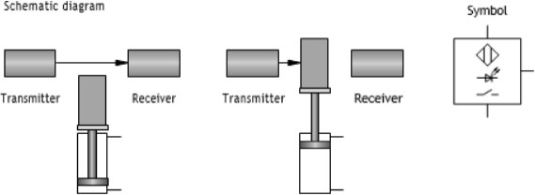**One-way light barrier**

The one-way light barrier has partially separate transmitter and receiver units. The parts are mounted in such a way that the transmitter beam is directed at the receiver. The output is switched if the beam is interrupted.

## Reflective light barrier

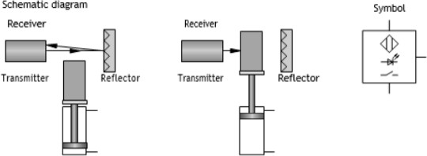

In the reflective light barrier, the transmitter and receiver are mounted together in one housing. The reflector is mounted in such a way that the light beam transmitted by the transmitter is practically completely reflected to the receiver. The output is switched if the beam is interrupted.

## 

## Diffuse reflective optical sensor



In the diffuse reflective optical sensor, the transmitter and receiver are mounted together in one unit. If the light hits a reflective object, it is redirected to the receiver and causes the output of the sensor to switch. Because of the functional principle, the diffuse reflective optical sensor can only be used if the material or machine part to be detected is highly reflective (for example polished metal surfaces, bright paint).

## Pressure sensor

* + There are various types of pressure-sensitive sensors:
  + Pressure switch with mechanical contact (binary output signal)
  + Pressure switch with electronic switching (binary output signal)
  + Electronic pressure sensor with analogue output signal

## Mechanical pressure switch

In the mechanically actuated pressure switch, the pressure acts on a cylinder surface. If the pressure exerted exceeds the spring force of the return spring, the piston moves and operates the contact set.

## Electronic pressure switches

Diaphragm pressure switches are of increasing importance. Instead of actuating a mechanical contact, the output is switched electronically. Pressure or force sensitive sensors are attached to the diaphragm. The sensor signal is evaluated by an electronic circuit. As soon as the pressure exceeds a certain value, the output is switched.

## Analogue pressure sensors

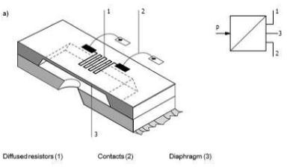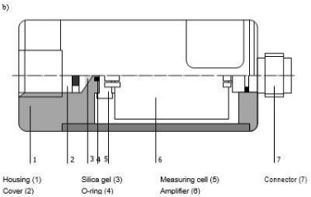

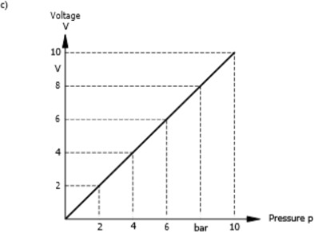

* The design and mode of operation of an analog pressure sensor is demonstrated using the example of the FestoSDE-10-10V/20mAsensor
* Fig. a shows the piezo resistive measuring cell of a pressure sensor. Variable resistor 1 changes its value when pressure is applied to the diaphragm. Via the contacts 2, the resist or is connected to the electronic evaluating device, which generates the output signal.
* Fig. b represents the overall construction of the sensor.
* Fig. c illustrates the sensor characteristics, representing the correlation between the pressure and the electrical output signal. Increasing pressure results in increasing voltage at the sensor output. A pressure of 1bar causes a voltage or 1V, a pressure of 2 bar a voltage of 2 V etc.

## Relay

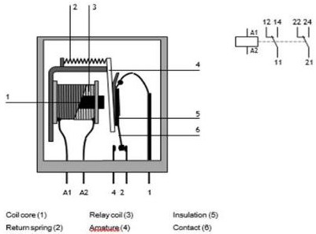

* + A relay is an electrically operated switch. Many relays use an electromagnet to mechanically operate a switch, but other operating principles are also used, such as a solid-state relay. Relays are used where it is necessary to control a circuit by a low power signal, or where several circuits must be controlled by one signal. Solid-state relays control circuits with no moving parts, instead of using a semiconductor device to perform switching.
  + A simple electromagnetic relay consists of a coil of wire wrapped around a soft iron core, an iron yoke that provides a low reluctance path for magnetic flux, a movable iron armature, and one or more sets of contacts. The armature is hinged to the yoke and mechanically linked to one or more sets of moving contacts.
  + The common contact switches between a normally closed contact and a normally open contact. The common contact is attached to an armature which is

strip of metal that is hinged at one end and has electrical contacts. A spring pulls the armature up so its contact connects to the normally closed contact. An electromagnet attracts the armature when it is energized and pulls it down so its contact disconnects from the normally closed contact and connects to the normally open contact instead.

## Applications of relays

* + - In electro-pneumatic control systems, relays are used for the following functions:
    - Signal multiplication
    - Delaying and conversion of signals
    - Association of information
    - Isolation of the control circuit from the main circuit.

## Retentive relay

* The retentive relay responds to current pulses:
* The armature is energized when a positive pulse is applied.
* The armature is de-energized when a negative pulse is applied.
* If no input signal is applied, the previously set switch position is retained (retention).

## Time relay

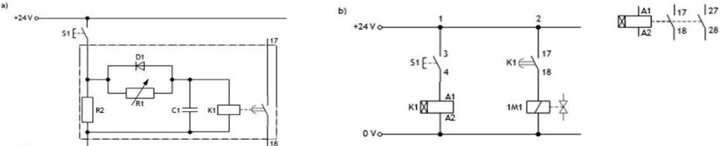

There are two types of time relay - pull-in delay and drop-out delay. With pull-in delay, the armature Is energized after a set delay; drop – out however, is effected without delay. The reverse applies in The case of the drop – out delay relay, whereby the contacts switch accordingly the time delay td can be set.

## Functional principle

* + When switch s1 is pressed current flows from variable resistor R1 to capacitor C1.
  + Diode D1 is connected in parallel so it will not allow current to flow in this direction
  + Current also flows from discharge resistor R2. When Capacitor C1 has charged, the relay switches.
  + When switch s1 is released, the current is interrupted and the capacitor discharges rapidly from diode D1 and resistor R2. After this the relay returns to its initial position
  + The Variable resistor R1 allows the charging current to the capacitor to be adjusted, thus also adjusting the time until the switching voltage for K1 is reached. If we put larger resistance, there a small amount of current is flows so the delay is long
  + If the resistance is low, large current Flows and the delay is short

## Contactor

A contactor has multiple switching elements, normally four to ten contacts. For contactors –as for relays –there are various types with combinations of normally open contact, normally closed contact, changeover contact, and delayed normally closed contact etc. Contactors that only switch auxiliary contacts (control contacts) are called contactor relays. Contactors with main and auxiliary contacts are called main or power contactors.

## Applications of contactors

Contactors are used for the following applications:

* + - Currents of 4 to 30 kW are switched via the main contacts of power contactors.
    - Control functions and logical associations are switched by auxiliary contacts.
    - In electro-pneumatic controllers, electrical currents and power are low. For this reason, they can be implemented with auxiliary contactors. Main or power contactors are not required.

## Introduction to programmable logic controllers (PLCs)

Control engineering has evolved over time. In the past humans were the main methods for controlling a system. More recently electricity has been used for control and early electrical control was based on relays. These relays allow power to be switched on and off without a mechanical switch. It is common to use relays to make simple logical control decisions. The development of low-cost computers has brought the most recent revolution, the programmable logic controller (PLC). The advent of PLC began in the 1970s and has become the most common choice for manufacturing controls. PLCs have been gaining popularity on the factory floor and will probably remain predominant for some time to come. Most of this is because of the advantages they offer.

•Cost effective for controlling complex systems.

•Flexible and can be reapplied to control other systems quickly and easily.

•Computational abilities allow more sophisticated control.

•Trouble shooting aids make programming easier and reduce downtime.

•Reliable components make these likely to operate for years before failure.

PLCs can be described by separating them into several functional groups. Many PLC manufacturers will organize these functions into individual modules; the exact content of each of these modules will likely be as diverse as are the applications. Many modules have multiple functions that can interface with multiple sensor interfaces. Yet other modules or expansion modules are often dedicated to a specific application such as a resistance temperature detector (RTD), sensor, or thermocouple sensor

## Signal processing

The signal processing part of an electro pneumatic controller consists of three function blocks. Its structure is shown in above figure

* Signal input takes place via two sensors so via push button or control switches.
* Fig. shows two proximity digital switches for signal input.
* Signal processing is normally undertaken by are lay control system or a PLC,
* control is undertaken by are relay control system.
* Signal output is via solenoid-actuated DCV‘s.

Above Fig show a schematic representation of a signal control section of an electro-pneumatic control system, in which relays are used for signal processing.

* + The components for signal input in Fig. inductive proximity switches 1B1 and 1B2 are connected via the controller inputs (I1, I2etc.) to their lay coils (K1, K2etc.)
  + Signal processing is implemented by means so suitable wiring of several relay coils and contacts.
  + The components for signal output (in Fig: solenoid so directional control valves 1M1 and 1M2 ) are connected to the controller outputs (O1 ,O2etc.). They are actuated via the relay contacts.

## Signal control section with programmable logic controller (PLC)

Fig shows the signal control section of an electro pneumatic control system in which a PLC is used for signal processing.

* + - The components for signal input in Fig, inductive proximity switches 1B1 and 1B2 are connected to the inputs of the PLC (I1, I2).
    - PLC microprocessor undertakes all signal processing tasks.
    - The components for signal output in Fig., solenoids of dcv1M1 and 1M2are connected to the PLC outputs (O1, O2 etc.). They are actuated by electronic circuits that are part of the microprocessor system.

# EXERCISE SESSION

**Draw the Pneumatic Circuit Diagram with Fluid Sim Software**

* 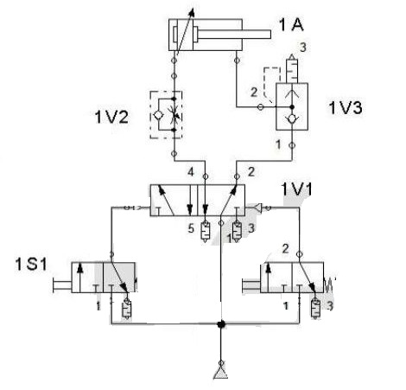Double Acting cylinder with adjustable end cushioning at both end, direct control by 5/2 way DCV with direct pneumatic actuation on both side (through 3/2 way DCV manually operated with spring returned, normally closed), spring returned, pneumatic speed adjustment by one way FCV with outlet throttle at extension side & quick exhaust valve at retraction side
* 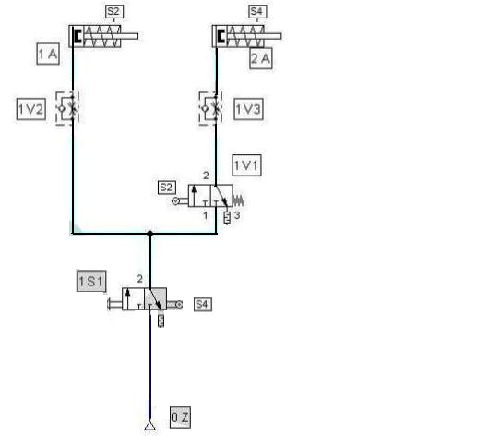When START switch (3/2 way DCV selection switch operated, normally closed) is pressed, Double Acting Cylinder with adjustable end cushioning at both end extends first & then retracts, this is repeated continuously still START switch is kept pressed. Pneumatic speed adjustment of cylinder is achieved by one-way FCV with outlet throttle on both side of the cylinder.
* Double Acting cylinder with adjustable end cushioning at both end, control by 5/2 way DCV with direct pneumatic actuation on both sides (Left Actuation: If both switches 1S1 AND1S2 are actuated, Right Actuation: If switch 1S3 OR1S4 is actuated), pneumatic speed adjustment by one way FCV with outlet throttle on both side. 1S1, 1S2, 1S3 & 1S4 are 3/2 way DCV push-button operated with spring returned, normally closed Day 11Day 11 is dedicated to Exercise session with Fluid sim software.

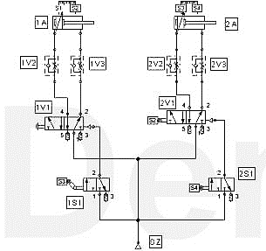

## Single Acting (Extension) cylinder sequencing:

When the START push button (3/2 way DCV push-button operated, spring returned, normally closed) is pressed, one cycle of the following sequence should be run. 1A Extends -> 2A Extends -> Both 1A & 2A Retracts Simultaneously Cylinder 1A & 2A are Single Acting cylinders & pneumatic speed adjustment by one way FCV with inlet throttle.

**Solution**

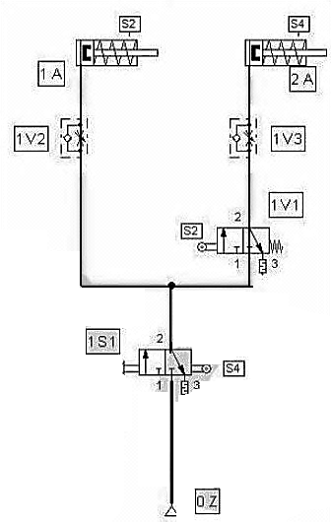

## Double Acting cylinder sequencing:

* When START push button (3/2 way DCV push button operated, spring returned, normally closed) is pressed, one cycle of the following sequence should be run. 1A Extends -> 2A Extends -> 2A Retracts -> 1A Retracts Cylinder 1A & 2A are Double Acting cylinders with adjustable end cushioning at both end & pneumatic speed adjustments by one way FCV with outlet throttle on both side of both cylinders 1A & 2A.
* When START push button (3/2 way DCV push button operated, spring returned, normally closed) is pressed following should be happened. Cylinder 1A should be extended immediately, cylinder 2A should be extended 10 seconds after 1A reaches its forward end position, cylinder 3A should be extended 10 seconds after 2A reaches its forward end position, cylinder 4A should be extended 10 seconds after 3A reaches it forward end position & all four cylinders should be retracted simultaneously immediately after cylinder 4A reaches its forward end position. All four cylinders (1A, 2A,3A & 4A) are Single Acting (Extension) cylinders.

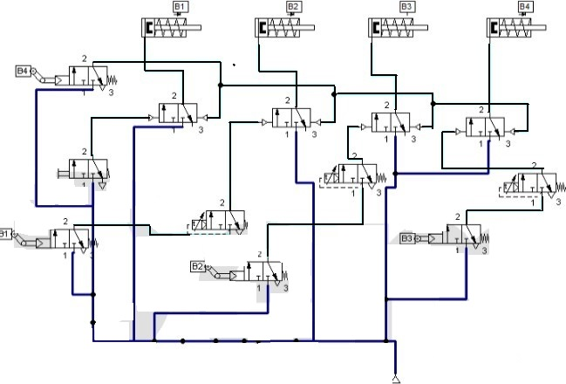

## ELECTRICAL CIRCUIT DIAGRAM

The electrical circuit diagram of a control system shows how the electrical control components are interconnected and how they interact. Depending on the task definition, the following types of circuit diagram are used in compliance with DIN/EN 61082-2:

* + Overview diagram
  + Function diagram
  + Circuit diagram

## Overview diagram

An overview diagram provides an overview of the electrical apparatus of a relatively large system, for example a packing machine or an assembly unit. It shows only the most important interdependencies. The various subsystems are shown in greater detail in other diagrams.

## Function diagram

A function diagram illustrates the individual functions of a system. No account is taken of how these functions are executed.

## Circuit diagram

A Circuit diagram shows the details of the design of systems, installations, apparatus etc. It contains:

* + Graphical symbols for the items of equipment
  + Connections between these items
  + Equipment identifiers
  + Terminal identifiers

## Electrical symbols

In a circuit diagram the components are represented by graphical symbols that are standardized according to DIN 40900. Symbols used to represent electrical

## Graphical symbols of Electrical symbols

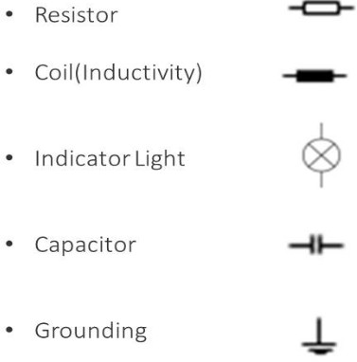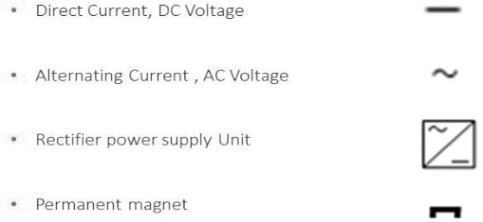

**Graphical symbols for contactors: Basic function and delay actuation**

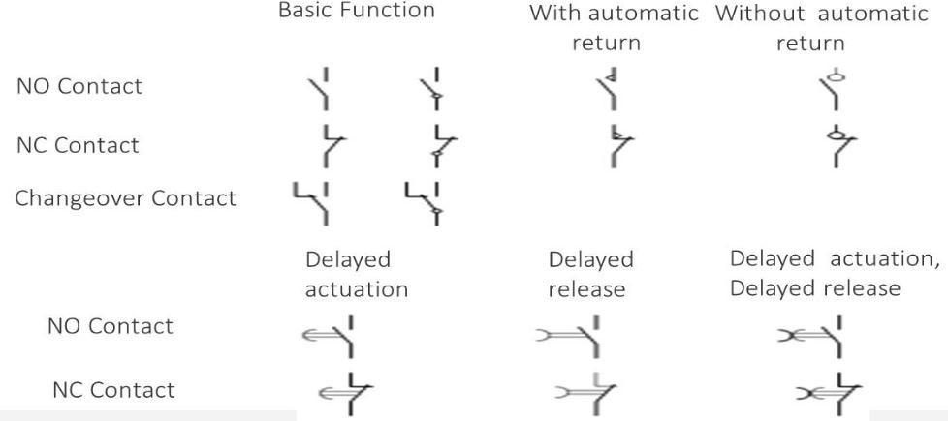

## Graphical symbols for contactors: Manually operated switching devices

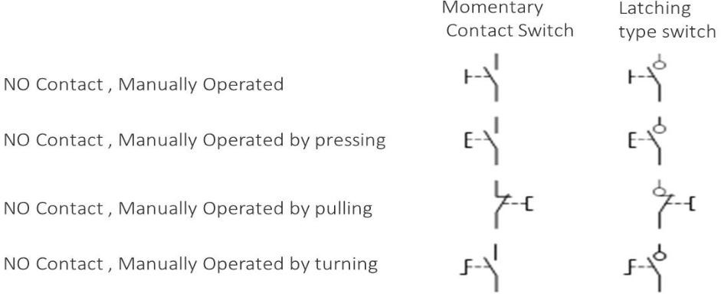

**Graphical symbols for electro mechanical device**

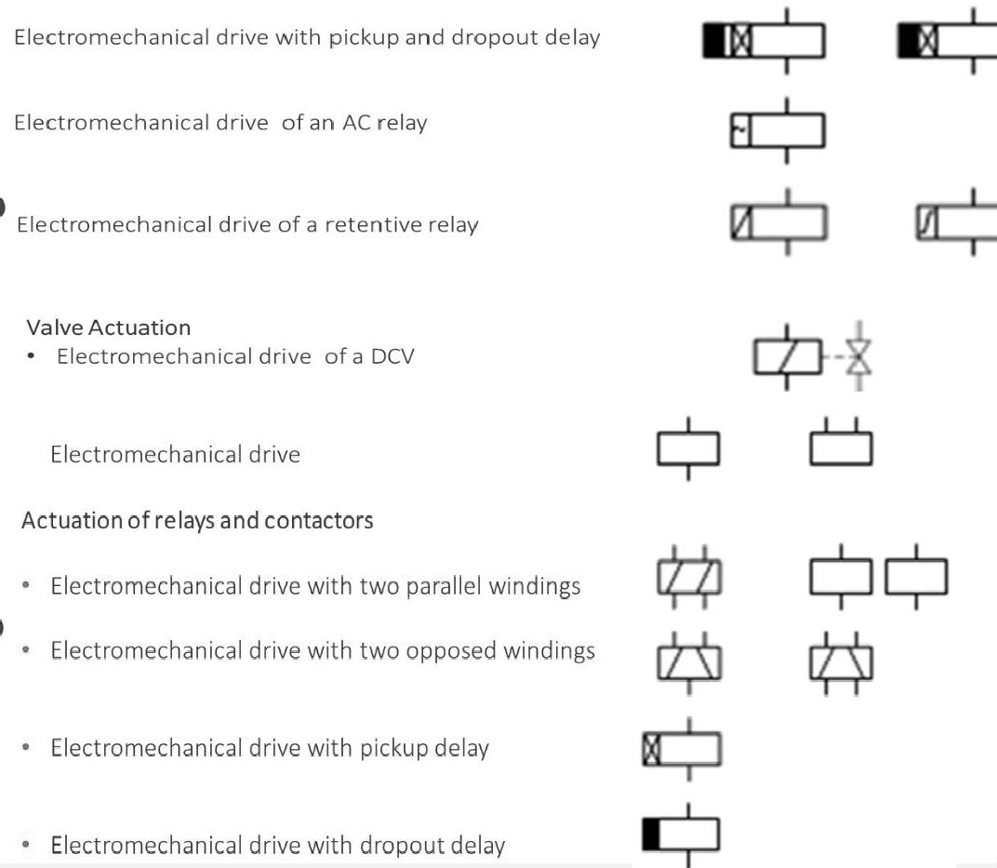

## Graphical symbols for relay and contactor

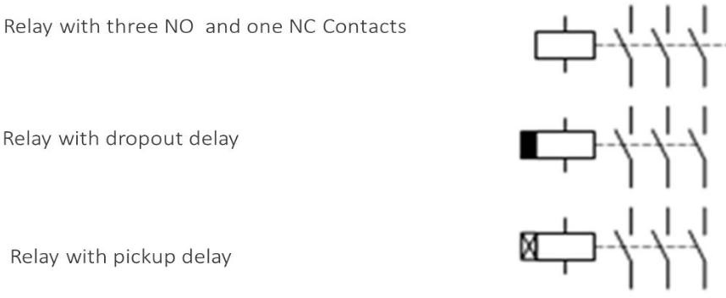

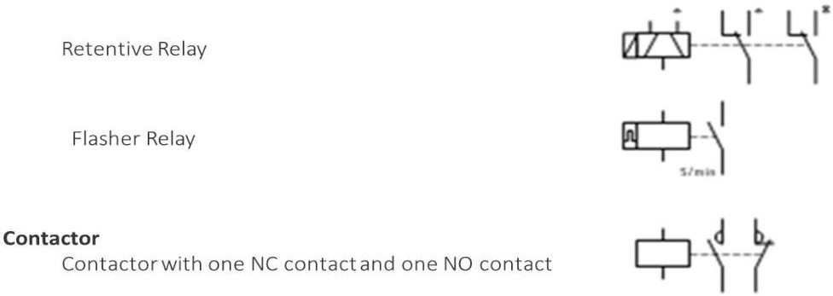

**Graphical Symbols for sensors**

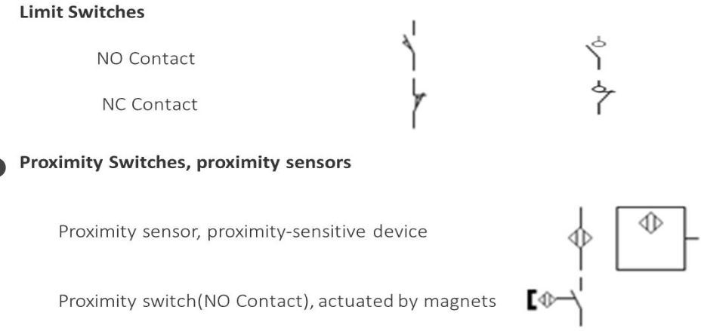

## Proximity Switches

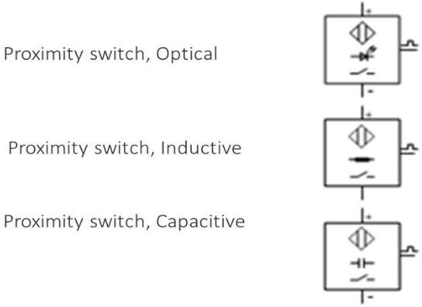

**Pressure switches**

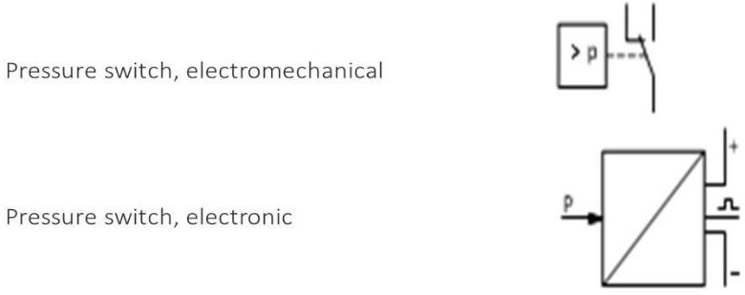

## Component Identification

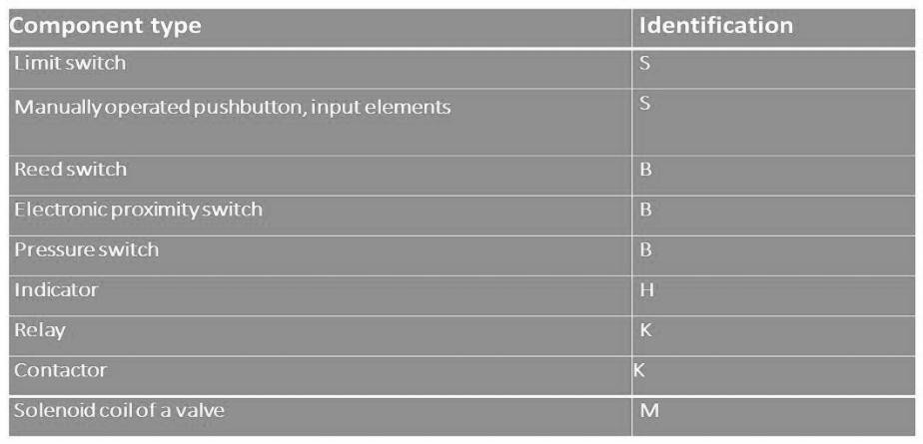

**Terminal Designation of Contacts and relay**

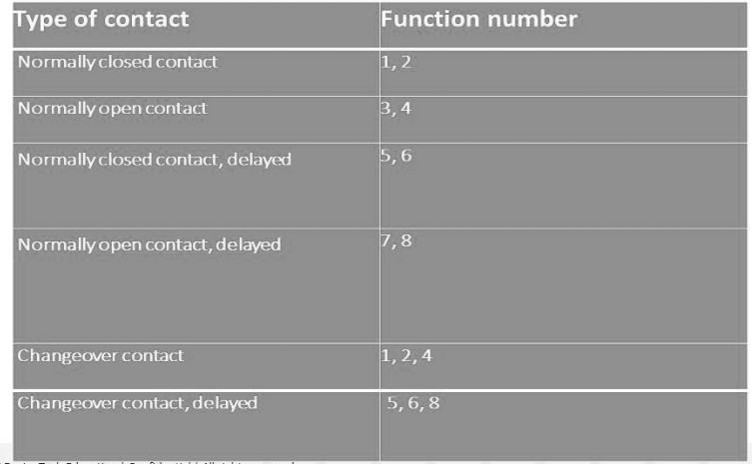

# 

# EXRSSICE SESSION

## Task 1

**Opening and closing Valve Training aim**

* + Direct actuation of a double-acting cylinder

## Exercise

* + Drawing the pneumatic and electric circuit diagram
  + Carrying out the pneumatic and electric circuit construction
  + Checking the sequence of the circuit

## Exercise description

* + Using a special device, the valve in a pipe line is to be opened and closed.
  + The valve is opened by pressing the pushbutton switch. When the pushbutton is released the valve is closed.

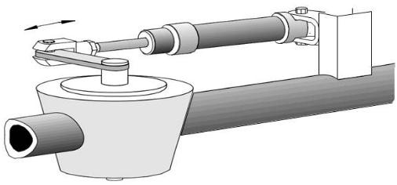

**Solution**:

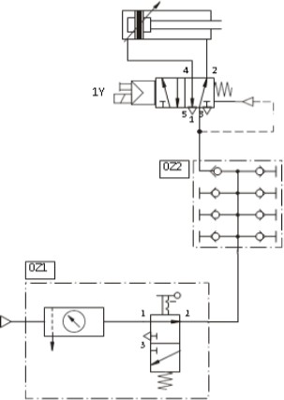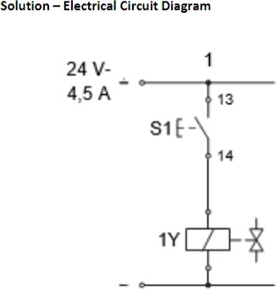

## Task 2 : sorting device

**Training aim:** Direct actuation of a single-acting cylinder

## Exercise

Drawing the pneumatic and electric circuit diagram Checking the sequence of the circuit.

## Exercise description

* + Using a sorting device, parts are to be transferred from a conveyor belt.
  + By pressing the pushbutton switch, the piston rod of a single-acting cylinder pushes the part off the conveyor belt
  + When the pushbutton is released, the piston rod returns to the retracted end position

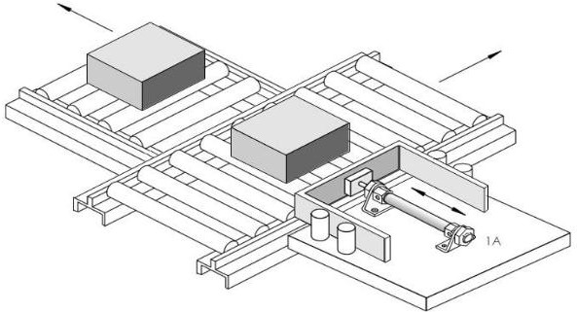

## Task 3: Training aims

Direct actuation of a double-acting cy

Operation of a 5/2-way valve with spring return and selector switch

## Exercise

* + Drawing the displacement-step diagram (without signal lines)
  + Designing and drawing the pneumatic circuit diagram
  + Function check
  + Adjusting the stroke times using the one-way flow control valves Note — Draw Pneumatic Circuit diagram with Fluid Sim software

## Exercise description

With the help of the vertical switching point, soft cool (lignite) briquettes are to be fed to an upper or lower conveyor, according to selection. The destination of the swiveling slide (upper or lower) is decided by means of a valve with selector switch. The upward motion of the double- acting cylinder (1A) is to take place in t; = 3 seconds; the downward motion in t, = 2.5 seconds. Pressure on both sides of the piston is indicated. In the initial position, the cylinder assumes the retracted End position

## Position sketch

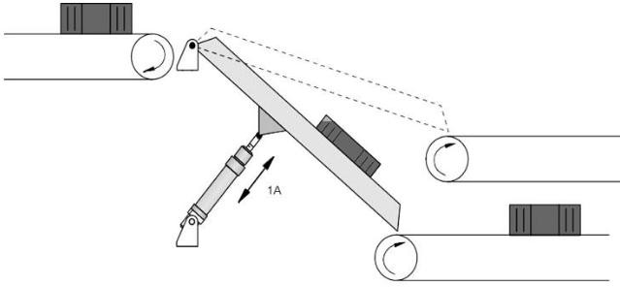

## Task 4 Turning Device Training aim

Indirect actuation of a single-acting cylinder

## Exercise

* + Drawing the pneumatic and electric circuit diagram.
  + Carrying out the pneumatic and electric circuit construction.
  + Checking the sequence of the circuit.

## Exercise description

* + By using a turning device parts are to be further transported on a conveyor track facing the right direction.
  + By pressing the pushbutton switch parts are turned by the piston rod of a cylinder and proceed, correctly positioned.
  + When the pushbutton is released the piston rod is returned to its start position.

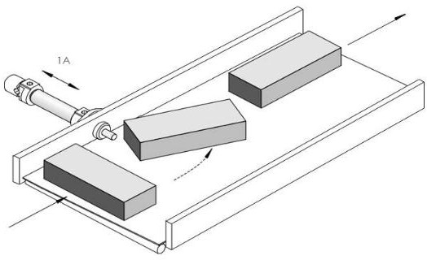

# ASSEMBLY SECTION

## Training Aim

* + Single-acting cylinder / Double-acting cylinder
  + Direct actuation with AND-function of the input signals

## Exercise

* + Drawing the pneumatic and electric circuit diagram
  + Carrying out the pneumatic and electric circuit construction
  + Checking the sequence of the circuit.

## Exercise description

* + In an assembly station components are to be put together.
  + By pressing two pushbutton switches the device is advanced and the components are assembled. After releasing the pushbutton switches, the device is returned to its start position.

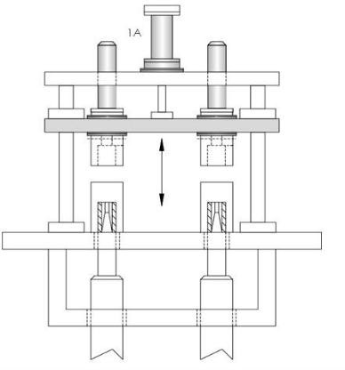

## Solution Electrical solution

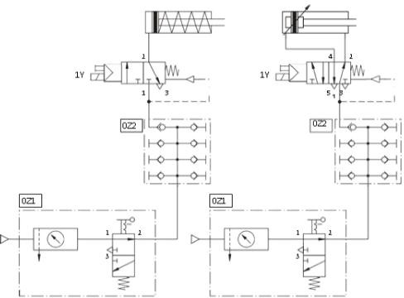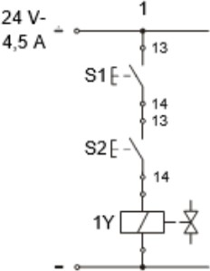

## Diverting Device

## Training aim

* + Single-acting cylinder / Double-acting cylinder
  + Direct actuation from two different positions

## Exercise

* + Drawing the pneumatic and electric circuit diagram
  + Carrying out the pneumatic and electric circuit construction
  + Checking the sequence of the circuit

## Exercise description

* + - Using a diverting device parts are to be moved from one conveyor track to another conveyor track.
    - By pressing a push button switch the frame of the diverting device is pushed forward. The part is moved over and transported on wards in the opposite direction. By pressing another push button switch the frame is returned to its start position.

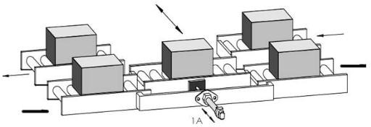

# TASK SESSION

## Task 1: The Problem

A single-acting cylinder of 25 mm diameter is to clamp a component when a push-button is pressed. As long as the push-button is activated, the cylinder is to remain in the clamped position. If the push button is released, the clamp is to retract.

## Exercise

* + Draw the circuit diagram for the problem.
  + Designate the valves and indicate the numbering system for the connections (ports).

## Positional sketch

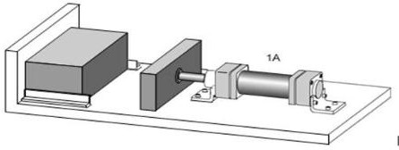

## Task 2

## Training aims

* + Operation of a single-acting cylinder
  + Direct actuation of a single-acting cylinder
  + Use of a 3/2-way directional control valve
  + Application of a service unit with on-off valve and manifold

## Problem

* + Drawing the displacement-step diagram in simplified form
  + Draw the pneumatic circuit diagram

The allocating device supplies aluminum valve blanks to a machining station. By operating a push button, the piston rod of the single-acting cylinder (1A) is made to advance. After release in, the actuating button, the piston rod returns

**Positional sketch**

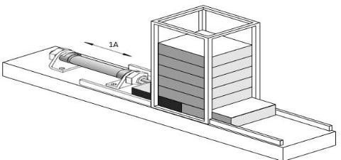

# EXPERIMENT

## Experiment 1

**Study of self-reciprocation of the single-acting cylinder using electric limit switch & 3/2 Solenoid Valve**

## Pneumatic Connection

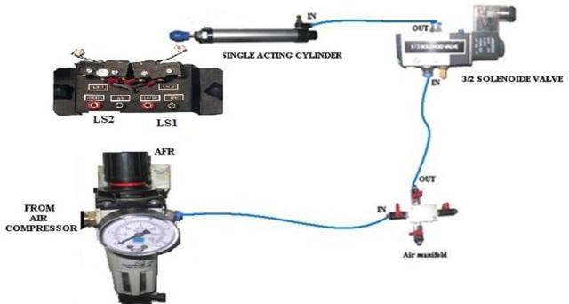

* + Experimental setup for study of Solenoid Valve is as shown in above diagram.
  + Connect the air compressor to the Air Filter Regulator. Give O/P of AFR to one of the terminal of the air manifold.
  + Start the compressor and built some air pressure with the help of AFR.
  + Give air supply to the I/P of the Solenoid Valve from the air manifold and give its O/P to the Single Acting Cylinder.
  + Do electrical connections as show in the connection diagram below.

## Circuit diagram for single-acting cylinder using 3/2 solenoid valve

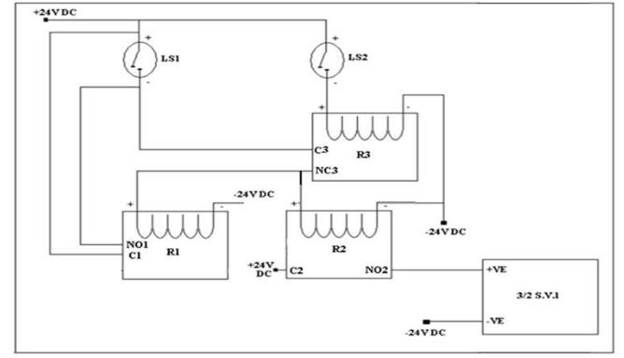

**Electrical Connection Procedure:**

* + Connect +24V DC to the + ive terminal (red) of LS1,C1 & C2.
  + Connect O/P (black) of the LS1 to the NO1& C3.
  + Connect +24V DC to the +ive terminal (red) of LS2.
  + Connect O/P (black) of the LS2 to the R3+.•Connect R3-to the -24V DC.
  + Connect NC3 to the R2+ & R1+.
  + Connect R2-& R1-to the -24V DC.
  + Connect NO2 to the + ive of the 3/2 S.V.
  + Connect –ive terminal of 3/2 S.V to the -24V DC.
  + Make the switches on the panel ‗ON‘.

## Operation:

* + As soon as the current flows through Solenoid Valve it starts operating and there is a pressure at the O/P which is given to the Single Acting Cylinder and because of this the shaft moves forward.
  + As the power supply removed, there is no pressure and the shaft retracts to its normal position. The complete operation is automatic as per electrical circuit

## Experiment 2 Study of AND gate

**Pneumatic connection**

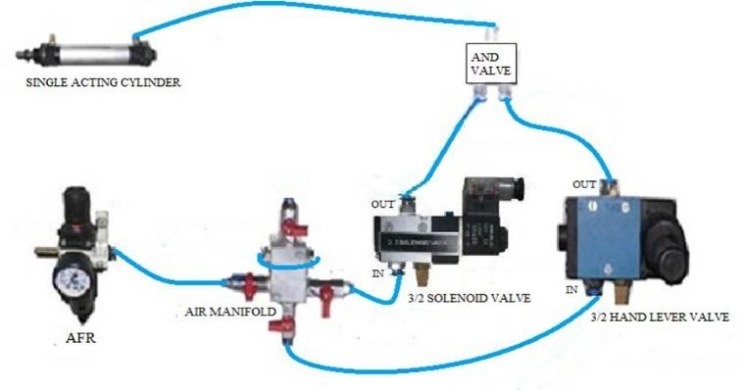

## Procedure:

* + Connect the air compressor to the AFR
  + The components required for this experiment are: AFR, Air manifold,3/2 way hand lever valve, 3/2 way solenoid valve (Actuate 3/2 SV using 24VDC supply or by pressing button on the valve manually), AND gate valve & single-acting cylinder.
  + Start the compressor, set the desired pressure through the AFR(preferably 2.1kg/cm²). Pull the knob of the AFR upwards, then rotate the knob to set the desired pressure. By rotating
  + AFR knob in clockwise direction the pressure increases. Push the knob downwards after setting the pressure to lock the AFR setting.
  + Do the pneumatic connections as shown in figure above.
  + Switch the respective inlet and outlet ports of air supply manifold ON.
  + Inlets to AND gate valve are given through 3/2 hand lever valve & 3/2 solenoid valve.
  + We have opened both the ports of manifold ON, but both inlets of the AND gate will be switched ON only if we actuate these two 3/2 way valves at a same time. Now the single acting cylinder actuates. The cylinder returns back to its home position when we stop anyone 3/2 way valve.
  + Hence, we can observe that, the AND gate valve gives output supply to the single acting cylinder if and only if we give pressure to. both inlets of the AND gate valve.
  + Observe the AND Gate Valve and single acting cylinder.

## Experiment 3 Study of shut valve

**Pneumatic Connection**

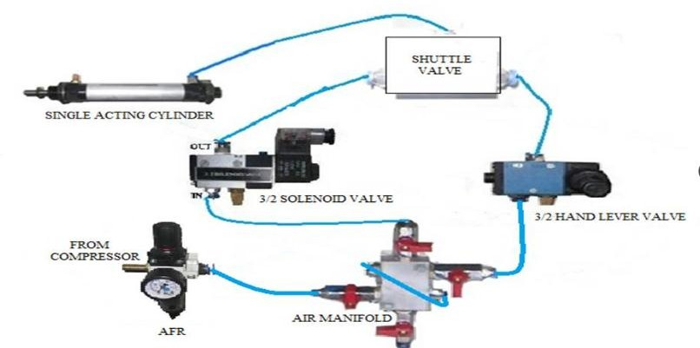

## Procedure:

* + Connect the compressor to the AFR.
  + Start the compressor, and set the desired pressure through the AFR.
  + (2.1 kg/cm²) Pull the knob of the AFR to UP, then rotate the knob to set the desired pressure. By rotating the AFR knob in clockwise direction the pressure increases while by rotating the knob in the anti-clockwise direction the pressure decreases. Push down the knob after setting the pressure.
  + Do the pneumatic connections as show in above figure
  + Operate 3/2 solenoid valve (using 24VDC supply or by pressing button on the valve manually) and 3/2-way hand lever valve and observe operation of SAC.
  + Shuttle valve works like OR GATE.

## Experiment 4

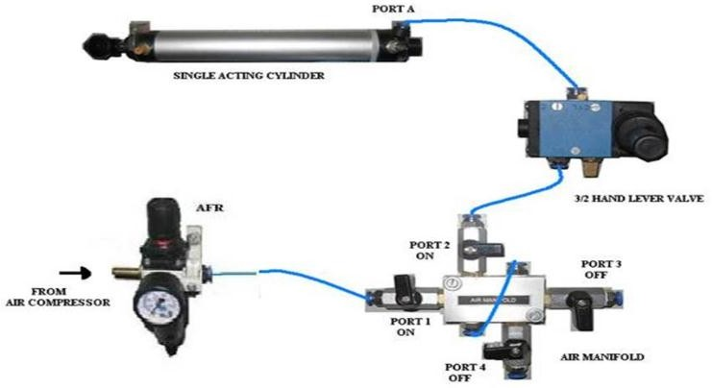**Study of Operation of 3/2 hand lever valve**

## Procedure:

* Connect the compressor to the AFR.
* Start the compressor, set the desired pressure through the AFR
* (2.1kg/cm²). Pull the knob of the AFR to UP, then rotate the knob to set the desired pressure.
* By rotating the AFR knob in the clockwise direction the pressure increases while by rotating the knob in the anticlockwise direction the pressure decreases. Push down the knob after setting the pressure.
* Do the pneumatic connections as show in the above figure.
* Keep Ball valves on Port 1 & Port 2 of air manifold ON & other ports are OFF.
* Operate the hand lever of 3/2 Hand Lever Valve.
* As the lever is moved in right hand side, then 3/2 hand lever valve supplies Air to the port A of the single acting Cylinder. So Single acting cylinder shaft moves forward.
* As the 3/2 hand lever is retracted then air supplied to port A of the single acting cylinder stops.
* So Single Acting Cylinder shaft returns to its home position because its spring return.

## C:\Documents and Settings\SAP-5\Desktop\New Folder\AFR\5BY2 PUSH BUTTON.bmpExperiment 5

**Study of 5/2 push button valve**

## Procedure:

* Connect the compressor to the AFR.
* Start the compressor, set the desired pressure through the AFR
* (2.1kg/cm²). Pull the knob of the AFR to UP, then rotate the knob to set the desired pressure. By rotating the AFR knob in the clock direction the pressure increases while by rotating the knob in anticlockwise direction the pressure decreases. Push down the knob after setting the pressure.
* Do the pneumatic connections as show above.
* Keep Ball valves on Port 1 & Port 2 of air manifold ON & other ports are OFF.
* Press the Button of the 5/2 push button valve. Double Acting Cylinder shaft moves forward.
* 6. If you release the push button then there is no force and the shaft retracts to its normal position.
* Observe double-acting cylinder.

## Experiment 6

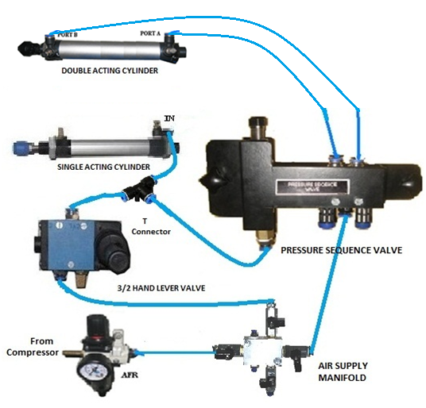**Study of pressure sequencing valve**

## Procedure to connect the compressor to the AFR.

* Start the compressor, and set the desired pressure through the AFR.
* Do the pneumatic connections as show above.
* Once you operate the 3/2 Hand Lever Valve, Single Acting Cylinder starts moving Forward When SAC reaches its final end position, the excess Pressure is diverted to Pressure Sequence Via T Connector.
* If this pressure is greater than the set pressure of the sequence valve, then the Sequence valve operate & Double acting Cylinder Starts moving Forward Direction.
* If you keep lever of 3/2 Hand Lever Valve is in its initial position, SAC return to its original position
* At same the moment Sequence valve pressure becomes less than Set Pressure Hence Sequence valve got its initial position & DAC return to its original position.

## Experiment 7

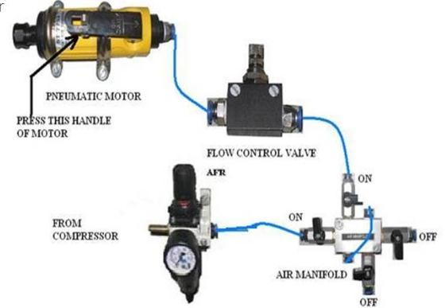**Study of flow control valve and pneumatic motor**

## Procedure:

* Connect the compressor to the AFR.
* Start the compressor, set the desired pressure through the AFR
* (4kg/cm²). For this, pull the knob of the AFR upwards & rotate the knob to set the desired pressure. By rotating AFR knob in clockwise direction the pressure increases while by rotating the knob in anticlockwise direction the pressure decreases. Push down the knob after setting the pressure. This sets the pressure supplied through the AFR
* Do the pneumatic connections as shown above.
* Switch the respective inlet and outlet ports of air supply manifold ON so that air supply will be delivered through the flow control valve to pneumatic motor.
* Press the handle on the motor, this causes the motor shaft to rotate.
* Rotate the Flow Control Valve‘s knob & adjust the speed of pneumatic motor as desired.

## Experiment 8

**Study of P to E converter**

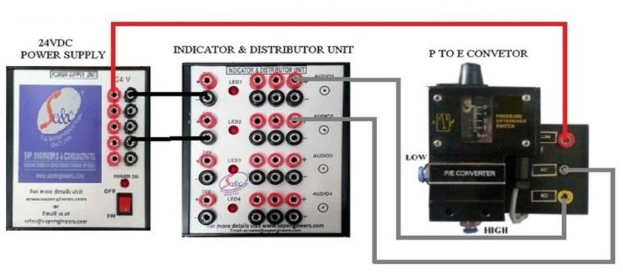

### Experiment 8a

* + **P to E as vacuum switch**

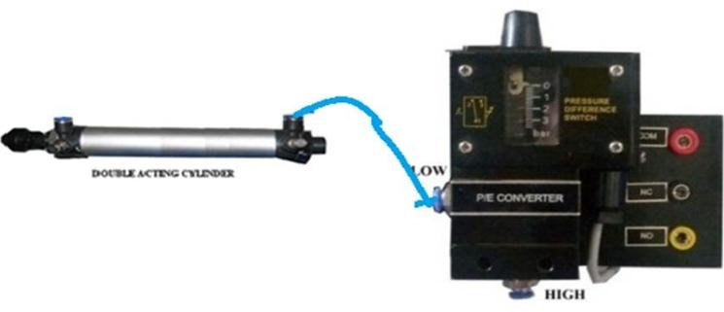

## Procedure:

* + Connect common to +24V power supply.
  + Connect NO and NC to +24V of distributer (Red Test Points as shown in Diagram)
  + Make the electrical connection as shown in above.
  + Also connect double acting cylinder to lower side or P to E (as shown in above fig).
  + Initially NC port of P to E convertor on.
  + 6. Pull the piston, vacuum is created and the NO port LED on the indicator starts glowing along with its audio.
  + Keep the pressure difference on 0 bar by adjusting pressure difference knob on top of the PDS.

### Experiment 8b

* + **P to E as a differential pressure switch**

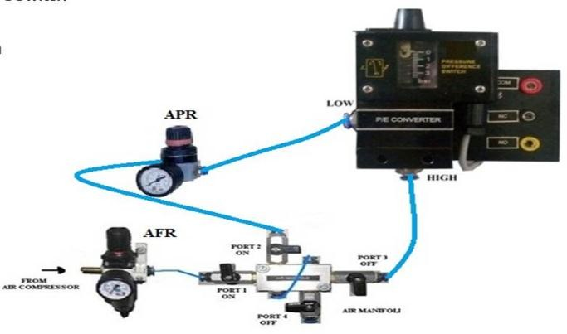

## Procedure:

* + Connect common to +24V power supply.
  + Connect NO and NC to +24V of distributer.
  + Make the electrical connection as shown above
  + Make pneumatic connections to PDS, AFR & APR (as shown in the above fig)
  + Set the pressure from AFR i.e. 4 kg/cm²
  + Set the pressure difference 1 bar by adjusting the pressure difference knob on top of the PDS.
  + Vary the pressure from APR above and below 3 kg/cm² and observe low level alarm and high level alarm

### Experiment 8c

* + P to E as pressure switch

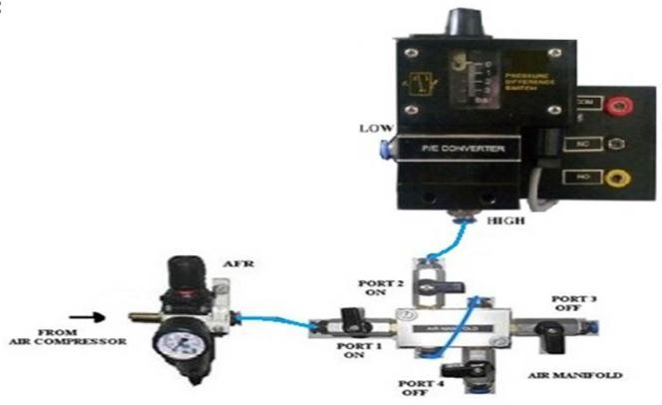

## Procedure:

* + Connect common to +24V power supply
  + Connect NO and NC to +24V of distributer (Red Test Points as shown in above Diagram)
  + Make the electrical connection as shown in the above electrical diagram.
  + 4. Also, connect the Air supply from the manifold to the higher side of P to E (as shown in the above fig)
  + Set the pressure on PDS= 2 bar
  + 6. When AFR pressure goes above 2 bar high-level alarm LED will be ON and below 2 bar
  + Low level alarm LED will turns ON.

## 

## Experiment 9

**Study operation of Time delay valve**

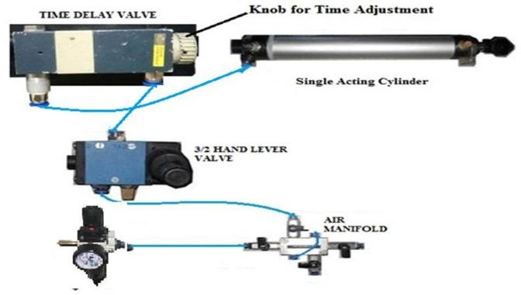

## Procedure:

* + Connect the compressor to the AFR
  + Start the compressor, set the desired pressure through the AFR
  + (2kg/cm²). For this, pull the knob of the AFR upwards & rotate the knob to set the desired pressure. By rotating AFR knob in clockwise direction the pressure increases while by rotating the knob in anticlockwise direction the pressure decreases. Push down the knob after setting the pressure. This sets the pressure supplied through the FRL
  + Do the pneumatic connections as show above.
  + Switch the respective inlet and outlet ports of air supply manifold ON
  + Operate 3/2 hand lever valve & observe the movement of Single Acting Cylinder with respect to time delay valve.
  + By using a knob, we can vary the time of the time delay valve.

## Experiment 10

**Study of operation of double acting cylinder by using Single input electrical box and 5/2 solenoid valve**

## Electric connection

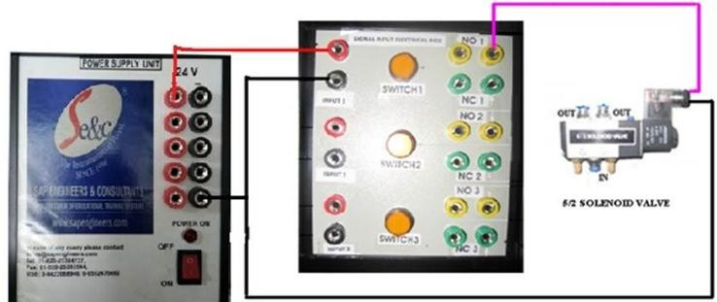

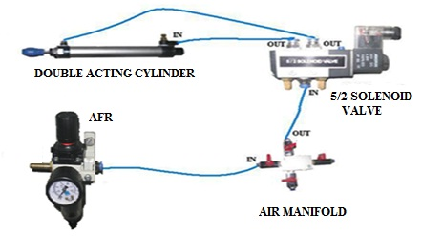**Pneumatic connection**

## Procedure:

* + Connect the air compressor to the Air Filter Regulator. Give O/P of AFR to one of the terminal of air manifold.
  + Start the compressor and built some air pressure with the help of AFR.
  + Give air supply to the I/P of the Solenoid Valve from the air manifold and give its O/P to the double Acting Cylinder.
  + Do electrical connections as show in the connection diagram below.
  + Press switch 1 on the signal input electrical box then the solenoid valve is switched ON Double-acting cylinder piston moves forward.
  + Release switch 1 then the solenoid valve gets switched OFF.
  + Double-acting cylinder piston returns to the home position.

# DO’S AND DONT’S

* Always keep the sufficient air supply pressure to the Electro-Pneumatic Trainer.
* To vary the pressure by AFR, first pull out the knob in upward direction. Clockwise rotation of the knob increases the pressure whereas anticlockwise rotation decreases the pressure.
* Keep the air filter regulator knob (AFR) in locked position at the pressure required for Particular experiment
* Once the supply pressure is set, do not play with the AFR knob.
* Adjust the flow control valve position such that piston of cylinder oscillates smoothly.
* Always maintain the pressure in the compressor more than 2.5kg/cm².
* Always keep switches off when trainer not in use.
* Keep the proximity sensors at the right position.
* Maintain oil level in the compressor.
* Do necessary connection of tubing as per the diagrams and perform the experiments